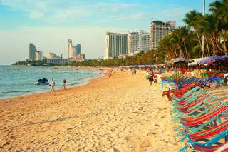

Pattaya One Day Tour
(1,500.- Baht / Per Person)

06.30 - 07.00 a.m. Pick up from the major hotel in Bangkok centre, transfer by join seat in coach to Pattaya.
09.00 - 09.30 a.m. Arriver Pattaya continue tour to Coral island by boat.
A little way off Pattaya, there 3 slams islands well known for their powdery sand, colorful corals and other forms life under the sea, which can be viewed conveniently from the glass-bottomed boats
12.00 a.m. Lunch at local restaurant on the island. After lunch your free time to relax, swimming or enjoy sport beach till time to transfer back to Bangkok.
03.00 a.m. Return to Bangkok by join seat in coach.
06.00 a.m. Arrival Bangkok, transfer to your hotel.
Price exclude
- Personal Expense
- Service charge 3.5% for paying by credit card charge

