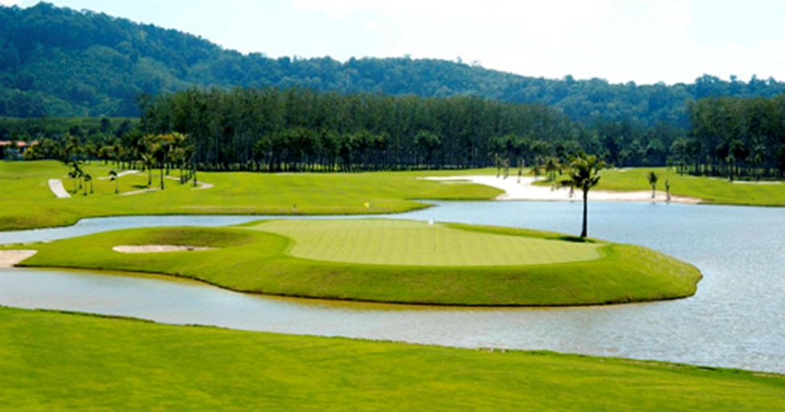
Golf Tour Package Itinerary For The River Kwai Golf Package

This golf tour package can be customized according to your preferences.
Day 1 - Transfer to Kanchanaburi
Transfer to River Kwai.
Day 2 - Golf at Mission Hills Golf Club Kanchanaburi
Golf at Mission Hills Golf Club Kanchanaburi (challenging Nicklaus design; beautiful surroundings).
Day 3 - Golf at Nichigo Golf Resort & Country Club
Golf at Nichigo Golf Resort & Country Club (area's most popular course, scenic and interesting design).
Transfer to Bangkok.
Start Location : River Kwai Kanchanaburi
Tour Length : 3 Days (Length can be adjusted)
Price From : 8,900

All accommodations
Inclusions :
- Daily breakfast
- All green fees
- 1 caddy per golfer at each golf course
- All airport, land, and golf course transfers
- All transfers by private VIP high roof touring van
- 24/7 golf hotline staffed by knowledgeable service personnel
- Local knowledge, expertise, suggestions, and support throughout trip
- All taxes and service charges
Exclusions :
- International airfare
- Personal items, drinks, and gratuities
Recommended Hotels :
- 4 Star U Inchantree Kanchanaburi Hotel
- We have a wide range of 3 - 5 star hotels available. To meet your preferences and budget please contact us for further information.
Extra Info : Escape now to Kanchanaburi, River Kwai for a couple of days.

