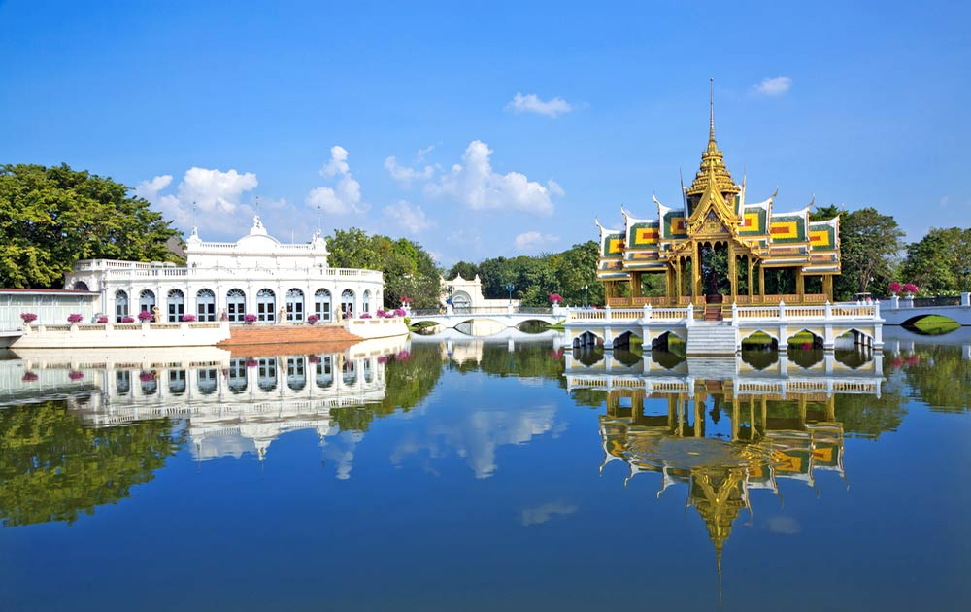
Ayuttaya 1 Day By Bus + Boat
(07.30 a.m. - 04.00 p.m.) (1,900.- Baht / Person)
Itinerary
07.15 a.m. Check in River City – Counter No.2 To Embark “Grand Pearl Coach”.
07.30 a.m. Depart Bangkok by air-conditioned coach visit Ayutthaya Ancient Capital.
09.00 a.m. Arrive Bang Pa-In Summer Palace , previously lived by many Thai monarchs from 17 th century. Bang Pa-In has a captivating collection of marvelous pavilions in a variety of Thai, Chinese, Italian and Victorian architectural styles, encircled by lush beautiful gardens and lake.
10.45 a.m. Arrive Ayutthaya one of the world heritage cities. Visit Viharn Phra Monkol Bopit The principal Buddha image is one of Thailand 's largest bronze.
11.15 a.m. Visit Wat Phrasrisanphet , This is the most important temple within the Royal Palace compound and corresponds to The Emerald Buddha Temple in Bangkok's Grand Palace.
12.15 a.m. Wat Chai Wattanaram constructed by King Prasathong in 1630.
01.30 p.m. Welcome onboard the luxurious cruiser “Grand Pearl” at Wat Chonglom ( Nualchawi Bridge ) Super buffet lunch which includes a delightful variety of oriental and western cuisines will be served. In the meantime, you will relax and enjoy the fascinating scenery on the River of Kings.
03.00 p.m. Coffee break will be served while you enjoy the enchanting sight along the river banks such as the Royal Barges, Thammasart University , the Royal Grand Palace and the graceful Temple Of Dawn.
04.00 p.m. Arrive at the River City Shopping Complex Pier.
Inclusions : A joined roundtrip air-conditioned transportation (BKK-Ayutthaya), Admission fee to all places indicated in the program, Lunch, A join cruise, English speaking guide.
Price exclude:
- Personal Expense
- Service charge 3.5% for paying by credit card charge

*PRICE AND ITINERARY ARE SUBJECT TO CHANGE WITHOUT PRIOR NOTICE*

