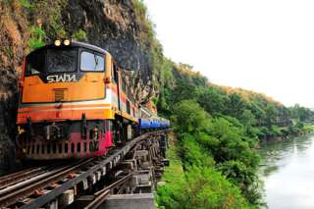
Kanchanaburi One Day Tour (1,900 Baht/Person)
War Museum (Thailand-Burma Railway Centre), War Cemetery,
Scenic Boat Ride, River Kwai Bridge, Death Railway Train

06.00 - 06.30 a.m. Pick up from major hotel in Bangkok Downtown Area. Depart for Kanchanaburi.
10.00 a.m. Arrive at Kanchanaburi, visit to War Museum (Thailand-Burma Railway Centre) and War Cemetery. Exciting the scenic boat ride lead you to enjoy the differences of three rivers from Maeklong River to Kwai Noi and Kwai Yai River then view to the world famous River Kwai Bridge.
12.00 a.m. Lunch at Pakseng Pier.
01.00 p.m. Take a ride through history on the Death Railway Train, passing lush forest scenery.
02.20 p.m. Continue by air-conditioned vehicle to Bangkok.
06.00 p.m. Arrive Bangkok and transfer to hotels.

Inclusions:
- A joined roundtrip air-conditioned transportation (Bangkok to Kanchanaburi)
- Admission fee to all places indicated in the program
- Lunch
- A joined roundtrip boat
- English speaking guide.
Exclusions:
- Optional tours or excursions not mentioned in the program
- Other meals not mentioned in the program
- Personal expenses
Note:
- Small deviations in the tour program are some times necessary, depending on road and time conditions
- Should there be any rejection of meals or sight-seeing tours from the clients cannot be claimed as a reason to be deducted from package tour price from our company, no matter partially or as a whole.
*PRICE AND ITINERARY ARE SUBJECT TO CHANGE WITHOUT PRIOR NOTICE*

