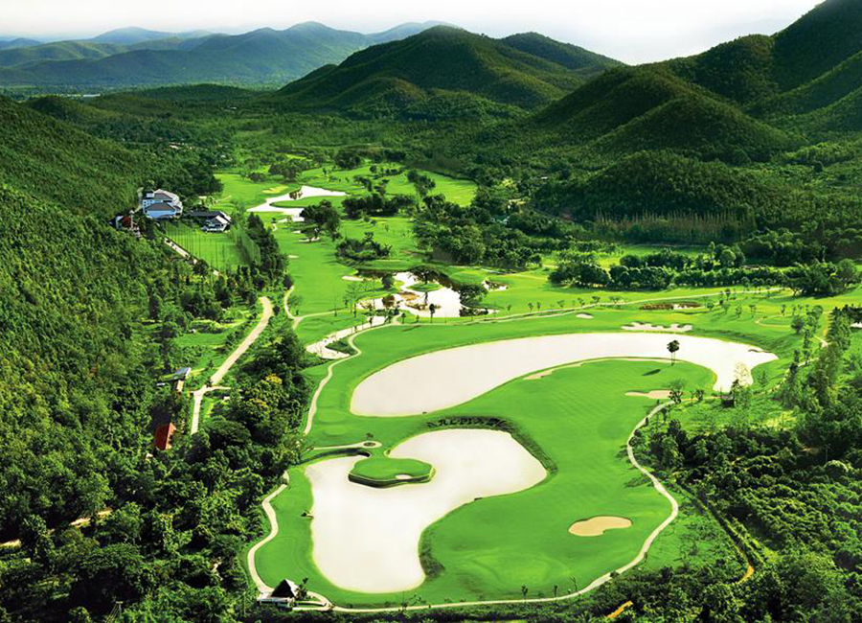

Golf Tour Package Itinerary for the Chiang Mai Golf Holiday

This golf tour package can be customized according to your preferences.
Day 1 - Arrival
Arrival Chiang Mai airport and transfer to hotel.
Day 2 - Golf at Alpine Golf Resort Chiang Mai
Golf at Alpine Golf Resort Chiang Mai (site of 2013/4 Asian Tour events is best conditioned Chiang Mai course).
Day 3 - Golf at Chiang Mai Inthanon Golf & Natural Resort
Golf at Chiang Mai Inthanon Golf & Natural Resort (top course with views of Thailand's tallest peak).
Day 4 - Golf at Chiang Mai Highlands Golf and Spa Resort
Golf at Chiang Mai Highlands Golf and Spa Resort (#1 course in Chiang Mai; highly recommended).
Day 5 - Departure
Transfer to Chiang Mai airport for departure.

Start Location : Chiang Mai
Tour Length : 5 Days (Length can be adjusted)
Price from : 14,600
Inclusions :
- All accommodations
- Daily breakfast
- All green fees
- 1 caddy per golfer at each golf course
- All airport and golf course transfers
- All transfers by private VIP high roof touring van
- Local knowledge, expertise and support throughout trip
- 24/7 golf hotline staffed by knowledgeable personnel
- All taxes and service charges
Exclusions :
- International airfare
- Personal items, drinks, and gratuities
Recommended Hotels :
- 3 Star Duangtawan Hotel Chiang Mai
- 4 Star De Naga Chiang Mai
- 5 Star Anantara Chiang Mai Resort & Spa
- We have a wide range of 3 - 5 star hotels available. To meet your preferences and budget please contact us for further information.

