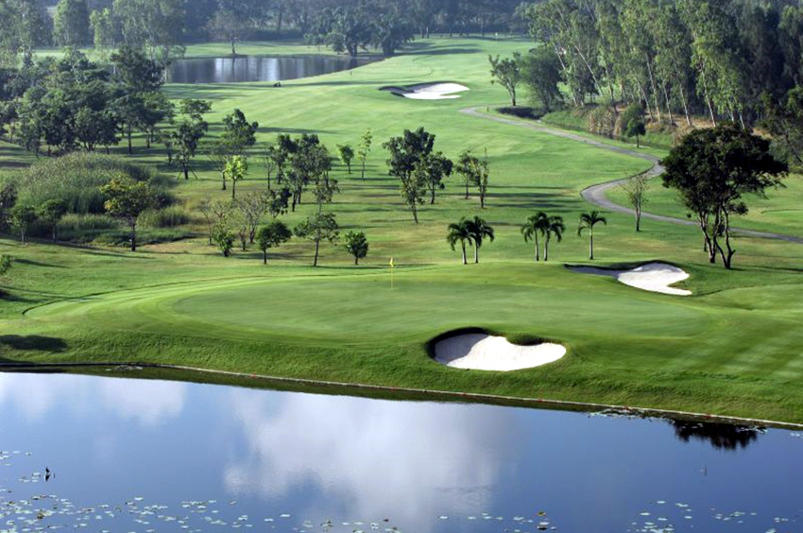

Golf Tour Package Itinerary for the Bangkok Golf Break

This golf tour package can be customized according to your preferences.
Day 1 - Arrival
Arrival Bangkok's Suvarnabhumi Airport and transfer to hotel.
Day 2 - Golf at Muang Kaew Golf Club
Golf at Muang Kaew Golf Club (well-maintained course with good variety is testing though enjoyable for all).
Day 3 - Golf & Departure - Golf at Thana City Golf & Sports Club
Golf at Thana City Golf & Sports Club (Greg Norman design with lots of variety & emphasis on shot making).
Transfer to Bangkok's Suvarnabhumi Airport for departure.

Start Location : Bangkok
Tour Length : 3 Days (Length can be adjusted)
Price from : 9,900

Inclusions :
- All accommodations
- Daily breakfast
- All green fees
- 1 caddie per golfer at each golf course
- All airport transfers
- All golf course transfers
- All transfers by private VIP touring van or equivalent
- 24/7 golf hotline staffed by knowledgeable service personnel
- All taxes and service charges
Exclusions :
- International airfare
- Personal items, drinks, and gratuities
Recommended Hotels :
- 3 Star The Palazzo, Bangkok
- 4 Star President Palace Hotel, Sukhumvit Soi 11
- 5 Star Sofitel Bangkok Sukhumvit
- We have a wide range of 3 - 5 star hotels available. To meet your preferences and budget please contact us for further information.
Extra Info : Golf courses may be substituted or changed as preferred.

