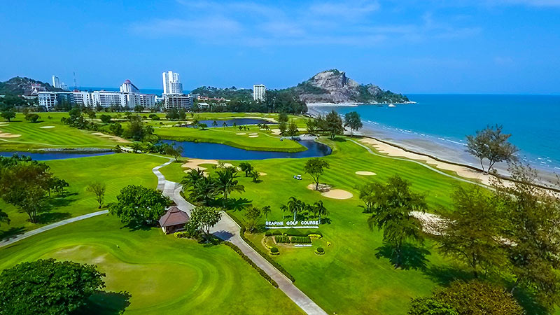

Golf Tour Package Itinerary for the Hua Hin - Bangkok (2-Destination) Golf Package

This golf tour package can be customized according to your preferences.
Day 1 - Arrival // Transfer to Hua Hin
Arrival at Bangkok airport and transfer to Hua Hin.
Day 2 - Golf at Sea Pines Golf Course
Golf at Sea Pines Golf Course (exciting links-style course on the Gulf of Thailand).
Day 3 - Golf at Springfield Royal Country Club
Golf at Springfield Royal Country Club (Nicklaus design is a long time area favorite).
Day 4 - Free day
Free day, at your own leisure.
Day 5 - Golf at Banyan Golf Club
Golf at Banyan Golf Club (2009 Best New Course In Asia: scenic & challenging).
Day 6 - Golf at Black Mountain Golf Club
Golf at Black Mountain Golf Club (1st class European Tour & Royal Trophy venue).
Day 7 - Golf at Nikanti Golf Club // Transfer to Bangkok
Golf at Nikanti Golf Club (unique all-inclusive course is one of Bangkok's best).
Transfer to Bangkok.
Day 8 - Free day
Free day, at your own leisure
Day 9 - Golf at Thai Country Club // Departure
Golf at Thai Country Club (prestigious members club has hosted PGA wins by Tiger Woods & Vijay Singh).
Transfer to Bangkok airport for departure.

Start Location : Hua Hin
Tour Length : 9 Days (Length can be adjusted)
Price from : 29,950

Inclusions :
- All accommodations
- Daily breakfast
- All green fees
- 1 caddie per golfer at each golf course
- All airport, land, and golf course transfers
- Transfers by Private VIP high roof touring van or equivalent
- Local knowledge, expertise, suggestions, and support throughout trip
- 24/7 golf hotline staffed by knowledgeable service personnel
- All taxes and service charges
Exclusions :
- International airfare
- Personal items, drinks, and gratuities
Recommended Hotels :
- 4 Star Baan Laksasubha Resort Hua Hin
- 4 Star Park Plaza Bangkok Soi 18
- 5 Star Centara Grand Beach Resort & Villas Hua Hin
- 5 Star Sofitel Bangkok Sukhumvit
- We have a wide range of 3 - 5 star hotels available. To meet your preferences and budget please contact us for further information.
Extra Info : Inquire about FREE Bangkok shopping tour including world's largest golf mall.

