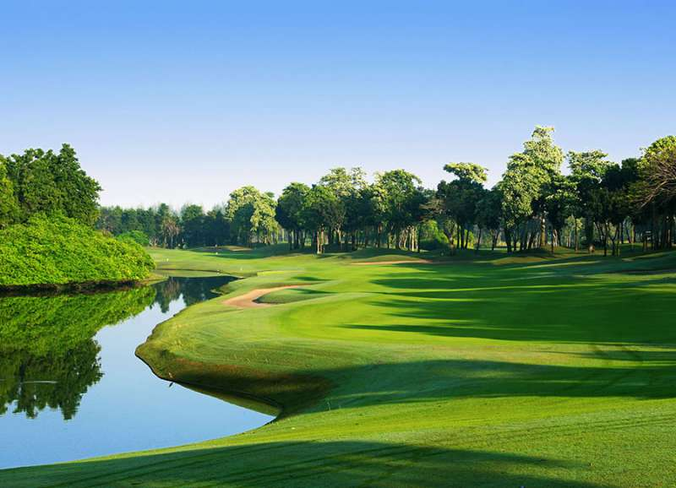

Golf Tour Package Itinerary for the One Week Bangkok Golf Package

This golf tour package can be customized according to your preferences.
Day 1 - Arrival
Arrival Bangkok's Suvarnabhumi Airport and transfer to hotel.
Day 2 - Golf at Suwan Golf & Country Club
Golf at Suwan Golf & Country Club (top course and site of 2010 Asian Tour International & 2011 Thailand Open).
Day 3 - Golf at Lam Luk Ka Country Club
Golf at Lam Luk Ka Country Club (top course & Asian Tour Q-School site).
Day 4 - Free
Free day at your own leisure.
Day 5 - Golf at Muang Kaew Golf Club
Golf at Muang Kaew Golf Club (well-maintained course with good variety is testing though enjoyable for all).
Day 6 - Golf at Pinehurst Golf & Country Club
Golf at Pinehurst Golf & Country Club (host of 1992 Johnnie Walker Classic & 1994 Thailand Open).
Day 7 - Departure
Transfer to Bangkok's Suvarnabhumi Airport for departure.

Start Location : Bangkok
Tour Length : 7 Days (Length can be adjusted)
Price from : 17,550

Inclusions :
- All accommodations
- Daily breakfast
- All green fees
- 1 caddie per golfer at each golf course
- All airport transfers
- All golf course transfers
- All transfers by private VIP high roof touring van
- 24/7 golf hotline staffed by knowledgeable personnel
- All taxes and service charges
Exclusions :
- International airfare
- Personal items, drinks, and gratuities
Recommended Hotels :
- 3 Star The Palazzo, Bangkok
- 4 Star Park Plaza Bangkok Soi 18
- 5 Star Sofitel Bangkok Sukhumvit
- We have a wide range of 3 - 5 star hotels available. To meet your preferences and budget please contact us for further information.
Extra Info : Alternate Bangkok golf courses and non-golf options available on request.

