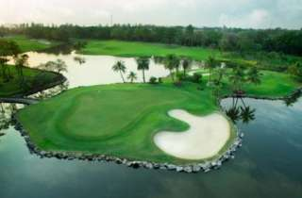
Golf Tour Package Itinerary for the Bangkok New Golf Courses Package

This golf tour package can be customized according to your preferences.
Day 1 - Arrival
Arrival Bangkok's Suvarnabhumi Airport and transfer to hotel.
Day 2 - Golf at Cascata Golf Club
Golf at Cascata Golf Club (wide fairways with large fast greens).
Day 3 - Golf at Suwan Golf & Country Club
Golf at Suwan Golf & Country Club (top course and site of 2010 Asian Tour International & 2011 Thailand Open).
Day 4 - Golf at Riverdale Golf Club
Golf at Riverdale Golf Club (dramatic elevation changes, same designer as Red Mountain in Phuket).
Day 5 - Departure
Transfer to Bangkok's Suvarnabhumi Airport for departure.

Start Location : Bangkok
Tour Length : 5 Days (Length can be adjusted)
Price from : 18,900
Inclusions :
- All accommodations
- Daily breakfast
- All green fees
- 1 caddie per golfer at each golf course
- All airport transfers
- All golf course transfers
- All transfers by private VIP high roof touring van or equivalent
- 24/7 golf hotline staffed by knowledgeable service personnel
- All taxes and service charges
Exclusions :
- International airfare
- Personal items, drinks, and gratuities
Recommended Hotels :
- 3 Star Citadines Bangkok Sukhumvit 16
- 4 Star Holiday Inn Bangkok Sukhumvit 22
- 5 Star Grand Hyatt Erawan Bangkok
- We have a wide range of 3 - 5 star hotels available. To meet your preferences and budget please contact us for further information.

