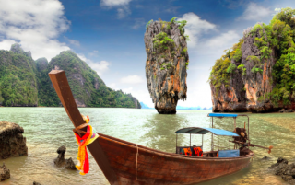

Phuket James Bond Island (Phang Nga Bay) Tour by Speedboat + Canoe
(Adult 2,000.- Baht / Person Child 1,600.- Baht / Person)

The Sea Mountains of Phang Nga Bay are so dramatic, that they impress everybody who ventures here. If you are really nature lover and concentrate to environment, it is completely appreciated. Our aim is to get you closer to the nature. In the same time, it is opportunity to touch with local people.
Itinerary :
- 08.30 - 09.00 a.m. Pick up time from hotel
- 10.00 a.m. Speedboat leave to Phang-Nga Bay
- Visit Panak Island & Ice Cream cave
- Visit Hong Island
- Visit James Bond Island
- Enjoy canoeing at Talu Island
- Have a great Lunch at Panyee Island
- Sightseeing Khao Khian
- 03.00 p.m. Swimming and relaxing at Lawa Island
- 03.00-03.30 p.m. Back to the pier and transfer to the hotel.
Tour Price included :
- Land Transfer Hotel / Pier / Hotel.
- Lunch and Seasonal fruits.
- Life Jackets.
- Canoe equipment with well-trained canoe paddler.
- Insurance.
- Educated staff.
- Excellent service.
Price exclude :
- Personal Expense
- Service charge 3.5% for paying by credit card charge
*PRICE AND ITINERARY ARE SUBJECT TO CHANGE WITHOUT PRIOR NOTICE*

