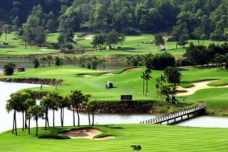
Golf Tour Package Itinerary for the Bangkok Championship Golf Package

This golf tour package can be customized according to your preferences.
Day 1 - Arrival
Arrival Bangkok's Suvarnabhumi Airport and transfer to hotel.
Day 2 - Golf at Thai Country Club
Golf at Thai Country Club (prestigious club has hosted PGA wins by Tiger Woods & Vijay Singh).
Day 3 - Golf at The Royal Gems Golf City (Dream Arena Course)
Golf at The Royal Gems Golf City (Dream Arena Course) (Augusta comes to Bangkok at Asia's first & only replica course).
Day 4 - Golf at Alpine Golf and Sports Club
Golf at Alpine Golf and Sports Club (site of Tiger Woods' 2000 Asian Tour win).
Day 5
Transfer to Bangkok's Suvarnabhumi Airport for departure.

Start Location : Bangkok
Tour Length : 5 Days (Length can be adjusted)
Price from : 21,400
Inclusions :
- All accommodations
- All green fees with pre-reserved tee times
- 1 caddie per golfer at each golf course
- All airport transfers
- All golf course transfers
- All transfers by high roof VIP touring van or equivalent
- 24/7 golf hotline staffed by knowledgeable service personnel
- All taxes and service charges
Exclusions :
- International airfare
- Personal items, drinks, and gratuities
Recommended Hotels :
- 3 Star The Palazzo, Bangkok
- 4 Star Dream Hotel, Bangkok
- 5 Star Sofitel Bangkok Sukhumvit
- We have a wide range of 3 - 5 star hotels available. To meet your preferences and budget please contact us for further information.
Extra Info : Additional golf and/or non-golf days can also be added.

