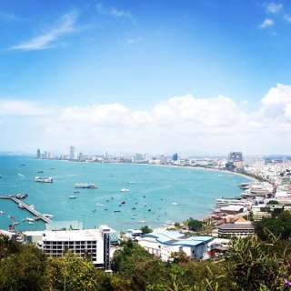
Golf Tour Package Itinerary for the Pattaya 2 Week Golf Holiday

This golf tour package can be customized according to your preferences.
Day 1 - Arrival in Bangkok / Transfer to Pattaya Arrival Bangkok's Suvarnabhumi Airport and transfer to Pattaya.
Day 2 - Golf at Siam Country Club, Waterside Course
Golf at Siam Country Club, Waterside Course (top layout, first class service, and great finishing holes).
Day 3 - Golf at Khao Kheow Country Club
Golf at Khao Kheow Country Club (popular Pete Dye design).
Day 4 - Free
Free day, at your own leisure.
Day 5 - Golf at Burapha Golf Club
Golf at Burapha Golf Club (site of 2010 Thailand Open).
Day 6 - Golf at Rayong Green Valley Country Club
Golf at Rayong Green Valley Country Club (picturesque and popular Peter Thomson course).
Day 7 - Free
Free day, at your own leisure.
Day 8 - Golf at St. Andrews 2000 Golf Club
Golf at St. Andrews 2000 Golf Club (unusual and exotic course with 2 par '6' holes).
Day 9 - Golf at Siam Country Club, Plantation Course
Golf at Siam Country Club, Plantation Course (spectacular Pattaya course is a 'must play'; site of 2009 USLPGA and 2015 Thailand Open).
Day 10
Free day, at your own leisure.
Day 11 - Golf at Laem Chabang International Country Club
Golf at Laem Chabang International Country Club (Nicklaus design is among Thailand's best).
Day 12 - Golf at Siam Country Club, Old Course
Golf at Siam Country Club, Old Course (Thai home of US LPGA).
Day 13 - Free
Free day, at your own leisure.
Day 14 - Departure
Transfer to Bangkok Suvarnabhumi airport for departure.

Start Location : Pattaya
Tour Length : 14 Days (Length can be adjusted)
Price from : 33,990

Inclusions :
- All accommodations
- Daily breakfast
- All green fees
- 1 caddie per golfer at each golf course
- All airport, land, and golf course transfers
- All transfers by VIP high top touring van or equivalent
- Local knowledge, expertise, suggestions, and support throughout trip
- 24/7 golf hotline staffed by knowledgeable personnel
- All taxes and service charges
Exclusions :
- International airfare
- Personal items, drinks, and gratuities
Recommended Hotels :
- 3 Star Areca Lodge
- 3 Star Mercure Pattaya Hotel
- 4 Star Woodlands Hotel & Resort
- 4 Star Rabbit Resort Pattaya
- 5 Star Sheraton Pattaya Resort
- We have a wide range of 3 - 5 star hotels available. To meet your preferences and budget please contact us for further information.

