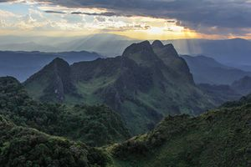
Chiang Dao - Elephant Safari,Bamboo Rafting,Orchid Farm & Lisu Hill Tribe

08:30 a.m. – 04:00 p.m.
Visit one of the best ways to explore Thailand 's natural wonders and be with nature is by elephants! Take a trip to touch the really vast and dense jungle atmosphere. Visit to Chiang Dao Elephant Training Camp , situated on the banks of the Ping River . The idea of this trip is to see the demonstration of how trained elephants are used as working animals in teak forests includes elephant bathing in the river, working in the jungle, Elephant painting, dragging and pushing logs and responding commands
Then experience exciting Elephant ride into the jungle for one and half hours past bamboo trees and hanging creepers, upwards towards a remote Lisu Hill TribeVillage, they are originated in Tibet and their villages are usually located in the mountains around 1,000 meters .
Lunch serve at the restaurant provided by the camp
Afternoon an experience trip by taking Bamboo River Rafting along Mae Ping River for 45 minutes, your relaxing time as the rafts men pole you down river through stunning scenery. Then drive to visit Orchid Nursery to see a large collection of more than 50 different types of colorful exotic year-round-bloom orchids. After taking great pleasure at the Orchid Nursery, then transfer back to the hotel
Included:
- Air-conditioned vehicles with experienced driver
- Service of English-speaking licensed guide
- Bottled drinking water during the tour
- Meals as mentioned in the program
- All entrance fees as mentioned in the program
Price exclude:
- Personal Expense
- Service charge 3.5% for paying by credit card charge

Full Day Tour  [Included Entrance Fee & Lunch] | 1 | 2 | 3-5 | 6-8 | Join Tour
Lampang - Elephant Safari At Thai Elephant Conservation | 4000 | 2500 | 2200 | 2000 | -
*PRICE AND ITINERARY ARE SUBJECT TO CHANGE WITHOUT PRIOR NOTICE*

