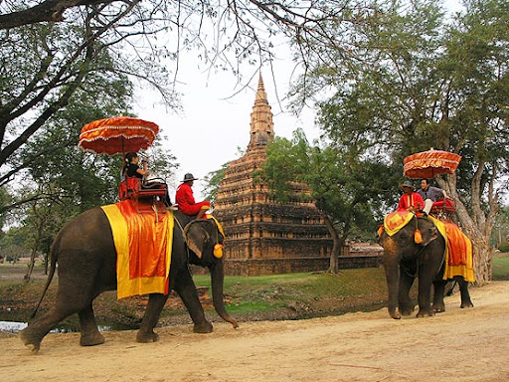
Mae Taman– Elephant Safari,Bamboo Rafting,Orchid Farm & Lisu Hill Tribe

08:30 a.m. – 04:00 p.m.
Travel north of Chiang Mai route to Mae Taman Elephant Camp , which is 56 km northwards of Chiang Mai. Enjoy the spectacular scenery along the way. The idea of this trip is to see the demonstration of how trained elephants are used as working animals in teak forests includes elephant bathing in the river, working in the jungle, Elephant painting, dragging and pushing logs and responding commands
Then take a special adventure time to Riding on Elephan t for one hour through the jungle, made a stop at Lisu Hill Tribe Village, they are originated in Tibet and their villages are usually located in the mountains around 1,000 meters . For the truly adventurous! Taking the local farmer transportation,ox-cart riding through rice fields & tropical fruit plantations return back to the elephant camp
Lunch serve at the restaurant provided by the camp
Afternoon an experience trip by taking Bamboo RiverRafting along Mae Taeng River for 45 minutes, your relaxing time as the rafts men pole you down river through stunning scenery. Then drive to visit Orchid Nursery to see a large collection of more than 50 different types of colorful exotic year-round-bloom orchids. After taking great pleasure at the Orchid Nursery, then transfer back to the hotel

Included:
- Air-conditioned vehicles with experienced driver
- Service of English-speaking licensed guide
- Bottled drinking water during the tour
- Meals as mentioned in the program
- All entrance fees as mentioned in the program
Price exclude:
- Personal Expense
- Service charge 3.5% for paying by credit card charge

Full Day Tour  [Included Entrance Fee & Lunch] | 1 | 2 | 3-5 | 6-8 | Join Tour
Mae Taman – Elephant Safari,Bamboo Rafiting,Orchid Farm & Lisu Hill Tribe | 3700 | 2500 | 2000 | 1600 | 1600
*PRICE AND ITINERARY ARE SUBJECT TO CHANGE WITHOUT PRIOR NOTICE*

