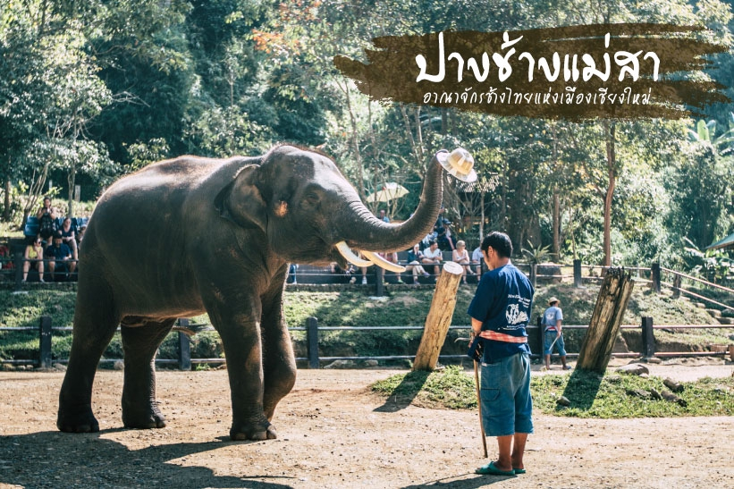
Mae Sa – Elephant Safiri , Bamboo Rariting ,
Orchid Farm & Lisu Hill Tribe
08:30 a.m. – 04:00 p.m.
Visit the magnificent Maesa Elephant Camp, 40 minutes to the northwest of Chiang Mai city, which is located on the banks of a small river, where the demonstration of how trained elephants are used as working animals in teak forests is given daily.
The show includes elephant bathing in the river, working in the jungle, elephant painting, dragging and pushing logs, and responding commands. This is your chance to enjoy an elephant ride around the camp (supplement will be paid on the spot).
A relaxing drive takes you up the slopes of Maesa Valley to visit a Meo Hill Tribe Village , who has own set of beliefs in spirituality and nature at “Baan Pha Nokkok“ to observe their simple way of life. The Meo hill tribe originated from South China and usually lives on mountain peaks above 3,000 feet.
Lunch serve at local restaurant
Continue to visit Queen Sirikit Botanical Garden , the first true botanical garden in Thailand . It is the center for botanical studies and research, render services concerning botanic and environmental knowledge as well as to provide recreation for public to enjoy the beautiful flora.
On the return to Chiang Mai stops are made at the Orchid Nursery to see a large collection of more than 50 different types of colorful exotic year-round-bloom orchids. Then transfer back to the hotel.
Included:
- Air-conditioned vehicles with experienced driver
- Service of English-speaking licensed guide
- Bottled drinking water during the tour
- Meals as mentioned in the program
- All entrance fees as mentioned in the program
Price exclude:
- Personal Expense
- Service charge 3.5% for paying by credit card charge

Full Day Tour  [Included Entrance Fee & Lunch] | 1 | 2 | 3-5 | 6-8 | Join Tour
Mae Sa – Elephant Safiri,Bamboo Rariting,Orchid Farm & Lisu Hill Tribe | 3500 | 2500 | 2000 | 1500 | -
*PRICE AND ITINERARY ARE SUBJECT TO CHANGE WITHOUT PRIOR NOTICE*

