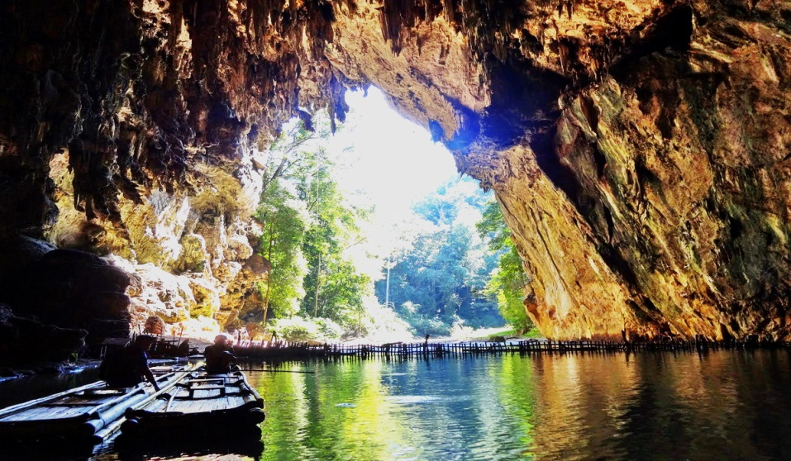
The Wonderfull Pai - Mae Hong Son Package 3 Days 2 Nights

Itinary
Day 1 L
Chiang Mai / Pai
07.45 a.m. Departure from Bangkok to Chiang Mai by plane
08.55 a.m. Arrival Chiang Mai
Pick up from Chiang Mai airport to Mae Hong Son by beautiful countryside road. Drive on some steep and winding roads through the mountains with various stops on the way, such as Mok Fha Waterfall , Pong Dued hot spring where the steam from the spring permeates the site in the morning creating fascinating sights. The area is also rich in teak woods.
On the way visit the Orchid Nursery to see a large collection of more than 50 different types of colorful exotic year-round-bloom orchids and beautiful Muakfah waterfall .
Lunch serve at a local restaurant at Pai town.
Afternoon, visit Wat Nam Hoo , the temple is best known for its sacred 'Pra Singha'-style Buddha image, called 'Un Mueang'. Casted in bronze, the head of the image is hollow and the water permeating from the head part is believed to be sacred.
Transfer to hotel Belle Villa Resort (Pai)
Free day at your leisure. In evening, you may walk around Pai night market.
Day 2 L,B
Pai / Lod Cave / Mae Hong Son / City Temples
Depart for Lod Cave where a huge cave system is once a dwelling place of pre-historic man. Experience with take the Bamboo raft reach into the cave; explore the 1 kilometer-long cave along which can be found beautiful stalactites and stalagmites. Also discovered are 2,000 year old remains of utensils and coffins.
Then drive on to visit Fish Cave , A special feature is the hollow cave filled with numerous freshwater fish, which is of the same family as the carp. The fish are quite safe from being caught as they are believed to belong to the gods.
Lunch serve at local restaurant Then transfer to the Mae Hong Son. Check-in at the hotel.
In afternoon, Start Mae Hon Son city tour to visit Wat Doi Klong Moolocated on a hill to the west of town, is a major provincial landmark. There are two Burmese-style Chedis. The larger one was built in 1860 while the smaller one was erected in 1874. A panoramic view of Mae Hong Son can be enjoyed from the site. Continue to Wat Jong Klang and Wat Jong Kum , magnificent Burmese style temples; there are several interesting items such as wooden figurines of human and animals depicted which means one of odd stories of former incarnations of the Buddha created by Burmese craftsmen. Transfer to hotel Imperial Mae Hong Song (Mae Hong Son)

Day 3 B
Mae Hong son / Long Neck Karen Village / Next Destinations
Take the boat trip along Pai River to visit the world famous Long Neck Karen Village where the women wear several brass rings around their long, slender necks. The Padong women famously wear brass rings around their necks. This distorts the growth of their collarbones and makes them look as if they have long necks - which they don't. This row of brass rings does not actually stretch their necks but in fact squash the vertebrae and collar bones. A woman generally has about twenty or more rings around her neck. This neck ring adornment is started when the girls are 5 or 6 years old. Then transfer to: Mae Hong Son airport for flight to Bangkok
05.05 p.m. Departure from Mae Hong Son
08.25 p.m. Arrival Bangkok (Flight transit at Chiang Mai)

Min. 02 paxs up & Join tour with English Speaking Guide
Price per person :
- Adult Thb. 19,900 (Twin or triple sharing)
- Adult Thb. 29,000 (single stay)
Price Included :
- 1 Accommodation at Belle Villa Resort (Pai)
- 1 Accommodation at Imperial Mae Hong Son (Mae Hong Son)
- Air Plane ticket Bangkok - Chiang Mai // Mae Hong Son - Chiang Mai - Bangkok By Thai Airways (Included Departure BKK airport tax & fuel charge).
- All private transfers and excursions as mentioned in the above itinerary
- Private air-conditioned transportation during the tour
- Excursions with good English-speaking guide
- Special Guide book with map about Northern Thailand
- Cold bottled drinking water during the tour
- Meals as mentioned in the program: 2 Lunch
- All entrance fees as mentioned in the above itinerary
Price Exclude :
- Service charge 3.5% in case of pay by credit card
- All meals and drinks not specified in the itinerary
- Personal expenses

*ALL PRICE AND ITINERARY ARE SUBJECT TO CHANGE WITHOUT PRIOR NOTICE*

