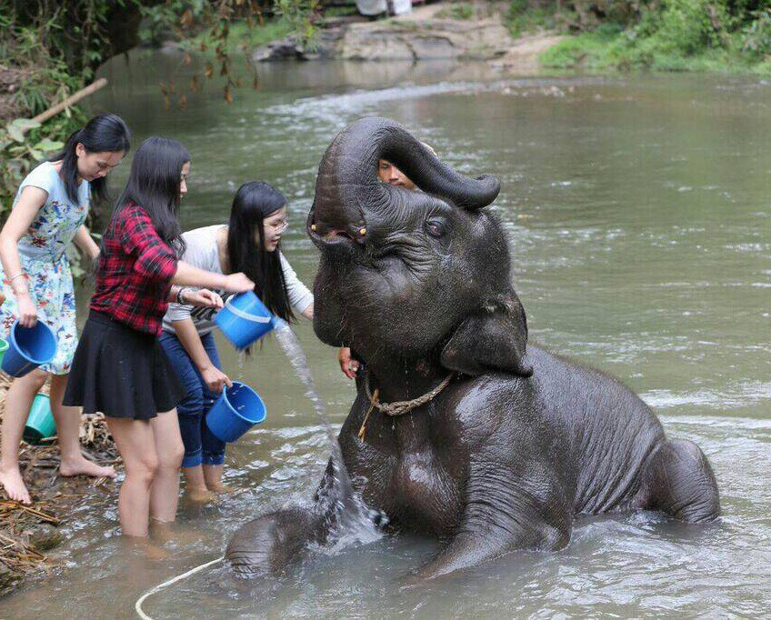
Package Chiang Mai 3 Days 2 Nights

Itinerary
Day 1 D
Bangkok – Chiang Mai
06.45 - 10.00 a.m. Departure for Chaing Mai by Thai Air Asia
07.55 - 11.10 a.m. Arrival Chiang Mai airport, welcome and transfer to Hotel Downtown Inn or similar Check in and free time.
01.00 p.m. Pick up at Hotel for join seat in coach tour of Doi Suthep and Phu Pink Palace. Wat Phrathat Doi Suthep , This temple was built in 1383. It is located 15 kms from the city and 3,500 feet above sea level. See the marvelous golden pagoda, which is containing the holy relics of Lord Buddha. This temple and its golden chedi attract Buddhist pilgrims from all over the world throughout a year. You can enjoy the panoramic view of Chiang Mai City and Ping valley from the summit of Doi Suthep. Wat Phrathat Doi Suthep is approached on foot by climbing a steep 306 stairway flanked by tremendous mythical Nagas, which symbolize humanity's progress from earth into nirvana. Continue to The winter residence for the Royal family during seasonal visits to the people in northern Thailand, Bhubing Palace , prominently featured is the beautiful Rose Garden featuring exotic cultivars, the Water Reservoir which is surrounded with landscaped beds of temperate flowering plants and the Fern Garden OR visit Meo Hill Tribe village to see how they live in the village. Finally transfer back to hotel. Free at your leisure
07.00 p.m. Pick up at hotel for enjoy Kantoke local dinner and show, after that free for shopping at night barzar or relax at hotel.
Day 2 B/L
Chiang Mai - Chiang Rai
Travel north of Chiang Mai route to Mae Taman Elephant Camp, which is 56 km northwards of Chiang Mai. Enjoy the spectacular scenery along the way. The idea of this trip is to see the demonstration of how trained elephants are used as working animals in teak forests includes elephant bathing in the river, working in the jungle, Elephant painting, dragging and pushing logs and responding commands
Then take a special adventure time to Riding on Elephant for one hour through the jungle, made a stop at Lisu Hill Tribe Village, they are originated in Tibet and their villages are usually located in the mountains around 1,000 meters . For the truly adventurous! Taking the local farmer transportation, ox-cart riding through rice fields & tropical fruit plantations return back to the elephant camp
Lunch serve at the restaurant provided by the camp
Afternoon an experience trip by taking Bamboo River Rafting along Mae Taeng River for 45 minutes, your relaxing time as the rafts men pole you down river through stunning scenery. Then drive to visit Orchid Nursery to see a large collection of more than 50 different types of colorful exotic year-round-bloom orchids. After taking great pleasure at the Orchid Nursery, then transfer back to the hotel

Day 3
Chiang Rai – Bangkok
Breakfast at hotel. Check out and Pick up you at hotel for travel to Chiang Rai by road ( 200 Km ) along picturesque scenic routes passing several beautiful northern mountains. Visit the Hot Spring at Mae Ka Chan district and continue to Rong Khun Temple (White's Temple ); designed by the famous national artist. The main temple building is a distinctive white color, decorated with fragments of reflective glass which can be seen from afar. Then visit the world famous Golden Triangle where the borders of three countries; Thailand , Laos , and Myanmar are met. See the Golden Buddha Statue and panoramic view of Mekong River . Experience the long-tail boat trip to view the splendor of mighty Mae Khong River and make a stop at Don Sao Village , Laos .
12:30 a.m. Lunch serve at the local restaurant on the bank of Mae Khong River .Continue to visit Mae Sai, the Thailand-Myanmar border which is also the northernmost point of Thailand . Enjoy shopping local products from China and Myanmar . Then drive on to visit the world famous Long Neck Karen Tribe Village ; the woman wears several brass rings around their long, slender necks. A woman generally has about twenty or more rings around her neck. They are originated from Shan state, The Union of Myanmar. Also visit nearby Akha Hill Tribe; the most beautiful women's head wares, decorated with assorted coins, shells, beats feathers and animals. They are originated from China .
05.00 p.m. tour end, transfer to Chiang Rai airport.
10.00 p.m. Departure for Bangkok by Thai Air Asia
11.50 p.m. Arrival Bangkok .
Price Per person :
- Price Per person : Thb. 9,500 (twin sharing) / 11,000 (single travel)

This price included:
- Return air ticket Bangkok – chiang Mai / Chiang Rai – Bangkok by Air Asia (fix flight/date –non refund)
- 2nights accommodation in twin sharing room at Down Town Inn hotel (Chiang Mai) included breakfast
- Join seat in coach tour to Doi Suthep Temple and Phupink palace or Hill Tribe village
- Joint seat in coach tour for dinner and show
- Joint seat in coach tour for Elephant camp, Orchid Farm and Lisu village.
- Join seat in coach tour to Chaing Rai Golden Triangle, Mae Sai & Chiang Saen city included lunch
- One way transfer in from airport to hotel Down Town
- One way transfer to Chiang Rai airport after tour end

Price Exclude :
- 3.5% service charge in case of pay by credit card
- All personal expense
Note:
- This is start price and able to increase follow up the cost of air ticket.
- Seats very limited for first come /first serve only
- Price valid now till 31 March 2010 but not valid for travel during long weekend or special holiday and subject to change without prior notice
*ALL PRICE AND ITINERARY ARE SUBJECT TO CHANGE WITHOUT PRIOR NOTICE*

