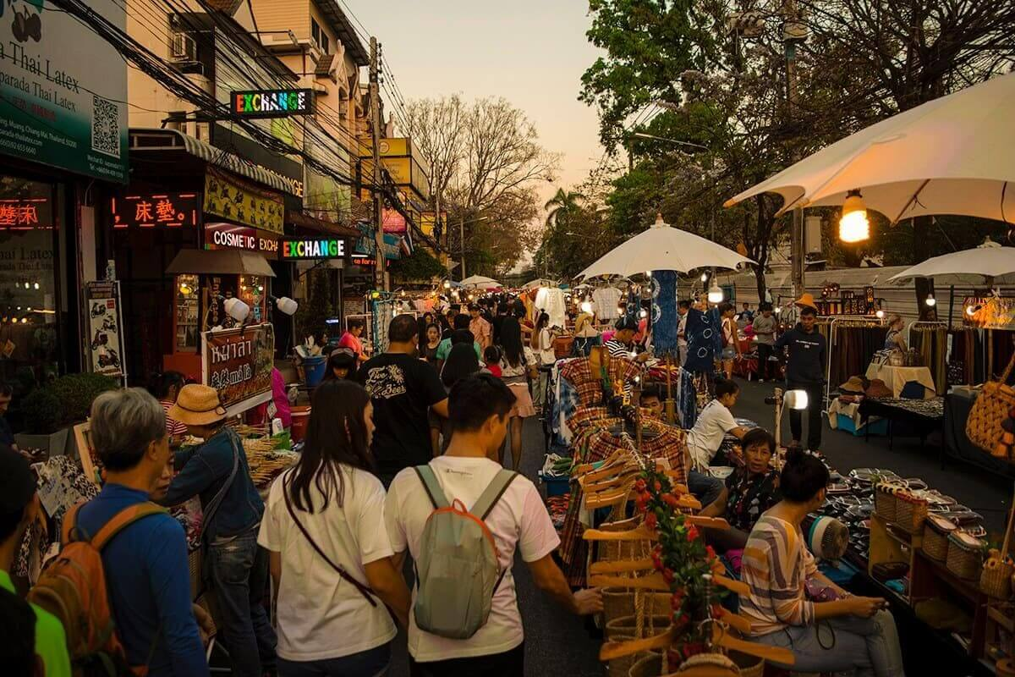
Package Chiang Mai 3 Days 2 Nights

Itinerary
Day 1
Bangkok – Chiang Mai
06.45 a.m. , 10.45 a.m. , 12.50 a.m. , 03.20 p.m. , 07.10 p.m. and 08.40 p.m. Departure for Chaing Mai by Thai Air Asia
07.55 a.m. , 11.55 a.m. , 02.00 a.m. , 04.00 p.m. , 08.20 p.m. and 09.50 p.m. Arrival Chiang Mai airport, transfer to Hotel Lotus Pangsuankaew
Check in (02.00 p.m.) at hotel and free time.

Day 2 B
Chiang Mai
Breakfast at hotel.
Then free at your leisure time for shopping, relax at hotel or buy the optional tour chiangmai.

Day 3
Chiang Mai – Bangkok
Breakfast serve at hotel restaurant.
Then free at leisure time till check out (1200) and transfer to airport for flight back to Bangkok .
08.25 a.m. , 12.25 a.m. , 02.35 p.m. , 05.05 p.m. , 08.50 p.m. and 10.20 p.m. Departure for Bangkok by Thai Air Asia
09.35 a.m. , 01.30 p.m. , 03.45 p.m. , 06.15 p.m. , 10.00p.m. and 11.30 p.m. Arrival Bangkok .

Min. 02 paxs up & Join tour with English Speaking Guide
Price Per person :
- 2, 3 Adults or 1 Adult+1 Child sharing in one room Thb. 5,000
- 1 Adult stay single room Thb. 6,000
- 1 Child stay with 2 adults Thb. 5,000 (with Extra bed)
- 1 Child stay with 2 adults Thb. 4,300 (no Extra Bed)

Extra Night (per room / night included breakfast)
- Twin room ( 2adults, 1Adt +1Chd or 1 Adt) Thb. 900
- Triple room (3 adults, 2Adt +1Chd with) Thb. 1,200
This price included:
- Return air ticket Bangkok – Chiang Mai– Bangkok by Air Asia (fix flight/fix date/ Nonrefundable)
- 2nights accommodation in twin sharing room at Lotus Pangsuankaew Hotel included breakfast and Transfer between Chiang Mai airport - hotel - Chiang Mai airport
Price Exclude :
- 3.5% service charge incase of pay by credit card
- All personal expense

Optional Tour :
- Elephant at Work, Riding Elephant, Bamboo Rafting at Mae Taeng = Thb. 1,600
- Discovery Long Neck Karen at North of Chiang Mai = Thb. 1,600
- Chiang Rai full day tour , Golden Triangle, Chiang Sean ancient city= Thb. 1,600
- Optional tour Chiang Mai
Note :
- Price valid now till 30 September 2011 but not valid for travel during long weekend & special holiday and subject to change without prior notice
- This is start price and seat very limited for first come /first serve only
*ALL PRICE AND ITINERARY ARE SUBJECT TO CHANGE WITHOUT PRIOR NOTICE*

