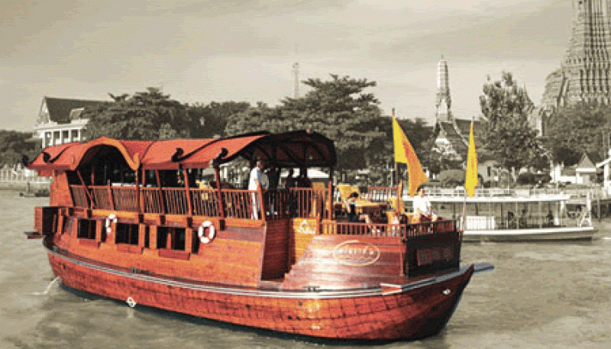
Ayuttaya 2 Days 1 Night (Overnight On Boat)
Day 1
BANGKOK - MEKHALA (D)
01.00 p.m. Pick up from hotel for transfer to Mekhala cruise pier
02.30 p.m. Start cruising up the Chao Phraya River with spectacular views of the Grand Palace and the Temple of Dawn . Just after the sunset, the MEKHALA docks at Wat Kai Tia, a Thai temple set in a tranquil rural village. An exquisite candlelit dinner of mouth-watering Thai cuisine is served on the deck. Overnight on board in your air-conditioned cabin.

Day 2
MEKHALA – AYUTHAYA (B)
An option for alms offering to monk can be made prior to a delicious breakfast served on board. Then depart for Bang-Pa-In Summer Palace where you will disembark nearby at approx. 10.00 a.m.
Sightseeing at Bang Pa-In Summer Palace, where is the most beautiful summer palace of Thailand . Here you will find various style of architecture such as Thai, Chinese, Spanish etc built in the beautiful area next to the bank of river.
Lunch at local restaurant.
After lunch visit to Ayutthaya Ancient city, The world heritage city. Visit Wat Mahatad, Wat Phrasrisanphet & Wiharn Phramongkhon Bophit. Finally return to your hotel in Bangkok .

Price per person :
- Now till 31 Oct 09
Thb.10,500 (Twin sharing cabin ) / Thb. 15,500 (single cabin/ Single travel )
- 1Nov 09 - 31Mar 10
Thb. 13,000 (Twin sharing cabin) / Thb. 17,500 (single cabin/ Single travel)

This price include:
- Pick up / Drop off from / To hotel in Bangkok
- Mekhala cruise trip up stream to Ayutthaya include one dinner and one breakfast
- Sightseeing tour in Ayutthaya ,admission fee, transportation, lunch and English speaking tour guide
Price exclude:
- Personal Expense
- Service charge 3.5% for paying by credit card charge

*PRICE AND ITINERARY ARE SUBJECT TO CHANGE WITHOUT PRIOR NOTICE*

