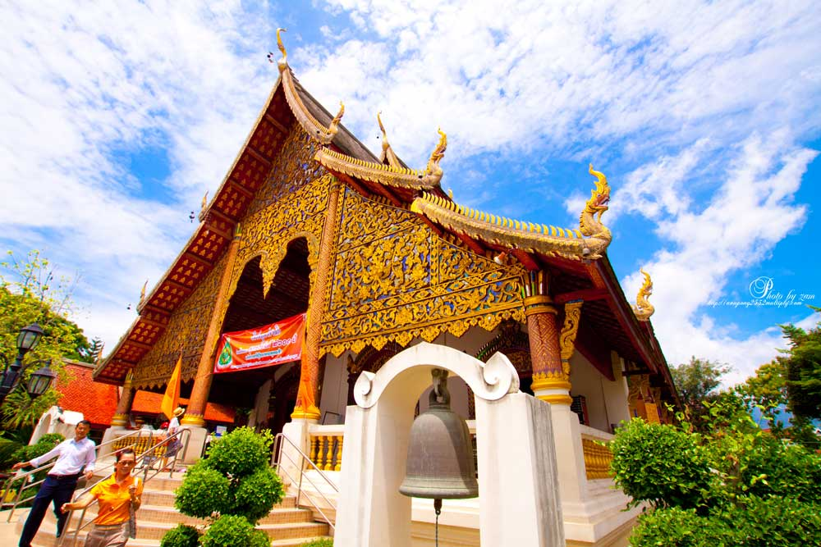
Chiang Mai City & Temple Tour
09:00 – 12:00 a.m. / 01:00 – 04:00 p.m.
Drive around the Old City to see city's moats and ruined city's walls. Start the temples tours with Wat Chiang Man, the oldest temple and probably dates from 1296. The temple was residence of King Mengrai, who founded Chiang Mai, and is noteworthy for a chedi supported by rows elephantine buttresses. Phra Buddha Sila inside is copy of the original indian image brought here from Ceylon in 1290.
Continue this tour with the most vital temple in Chiang Mai Wat Chedi Luang, where the great chedi called "Phra Chedi Luang" is situated. This five hundred-year-old chedi was built by King Sean Muang Ma to enshrine the relics of his father at the end of 14th century. Even though it was destroyed in an earthquake in 1545, it was to remain the tallest structure in Chiang Mai for over five centuries.
Also nearby is Wat Phra Singh, built by King Pha Yu to house the bones of his father King Kam Fu. The temple contains marvelous examples of Lanna art including a Lanna style viharn, "Viharn Lai Kham" and the finest small scripture repository of its type in the north.
Continue to Wat Suan Dok, built by King Keu Na of Lanna for a revered priest visiting from Sukhothai as a place for the monk to spend the rains retreat. The name of the temple roughly translates to "field of flowers." This temple is one of the first temple's large viharn , or prayer hall. The chapel is unusual not only for its size, but also the fact that it is open on the sides rather than being totally enclosed.
After that continue to eastern side of old city to Warorote Market, the biggest local Market in Chiang Mai which selling everything from clothes and textiles to fruit, herbs, flowers, vegetables, insect and even fireworks. Then transfer back to the hotel.

Included :
- Air-conditioned vehicles with experienced driver
- Service of English-speaking licensed guide
- Bottled drinking water during the tour
- All entrance fees as mentioned in the program
Price exclude :
- Personal Expense
- Service charge 3.5% for paying by credit card charge
Half Day Tour  [Included Entrance Fee] [AM & PM] | 1 | 2 | 3-5 | 6-8 | SIC
Chiang Mai City & Temple Tour | 1700 | 1200 | 1000 | 900 | -

*PRICE AND ITINERARY ARE SUBJECT TO CHANGE WITHOUT PRIOR NOTICE*

