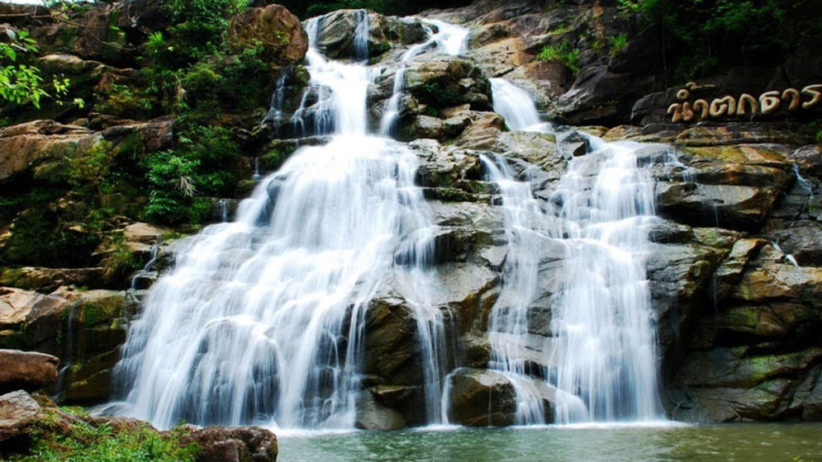
Pai Town – Unseen Beautiful Of Nature & Scenery

07:00 a.m. – 07:00 p.m.
This is your chance to see the beautiful town of Paiand several of the sights on the way. Pai is a wonderful, small town nestled in the hills of Mae Hong Son province in northern Thailand . Pai is in a beautiful setting and on the journey to Pai one encounters many wonderful sights.
Drive through scenery from Chiang Mai to Pai by mountain road along picturesque scenic routes passes the several beautiful northern mountains and valleys via Mok Fah Waterfall one of the highest waterfalls in Doi Suthep - Doi Pui National Park . Continue to visit Huay Naam Dung National Park , known for beautiful scenery especially in winter, when breathtaking views of mountains are surrounded under a sea of mist . Then continue drive on to Pai and made a stop at World War II Memorial Bridge , This Bridge was built in 1942, at that time the Japanese troops chose Pai to be their military base. Walk up to Pai Canyon : or Kong Lan, the steep cliff has been eroded for a long time ago, creating the 20 meter-deep valley amidst the scenic settings of the red hill of dry dipterocarp and pine forest.
Lunch serve at the local restaurant in Pai Town
Afternoon sightseeing the main attraction of Pai town; visit to Nam Hu Temple, contain a sacred Buddha image, 24 inches wide at the base and 30 inches high. The image's topknot can be opened and contained holy water, revered by local folk. Also nearby visit to Ban Santichon , one of the Chinese communities migrated from Yunan , China . Continue with city walking to visit Klang Temple , the main temple of Pai has a beautiful Shan style chedi and hall stands in the center. It's surrounded by low Mon Chedis, with Buddha images of the seven days of the week in niches. Then Drive to the hill to enjoy the panoramic view of Pai town at Mae Yen Temple , It's reported the view is as far as 10 kilometers. Relaxing at Tha Pai Hot Springs , there is a stream running through the hot springs and you can bath in the river. Then transfer back to Chiang Mai.
Included :
- Air-conditioned vehicles with experienced driver
- Service of English-speaking licensed guide
- Bottled drinking water during the tour
- Meals as mentioned in the program
- All entrance fees as mentioned in the program
Full Day Tour | 1 | 2 | 3-5 | 6-8 | Join Tour
Pai Town | 5800 | 3500 | 2500 | 2000 | -

*PRICE AND ITINERARY ARE SUBJECT TO CHANGE WITHOUT PRIOR NOTICE*

