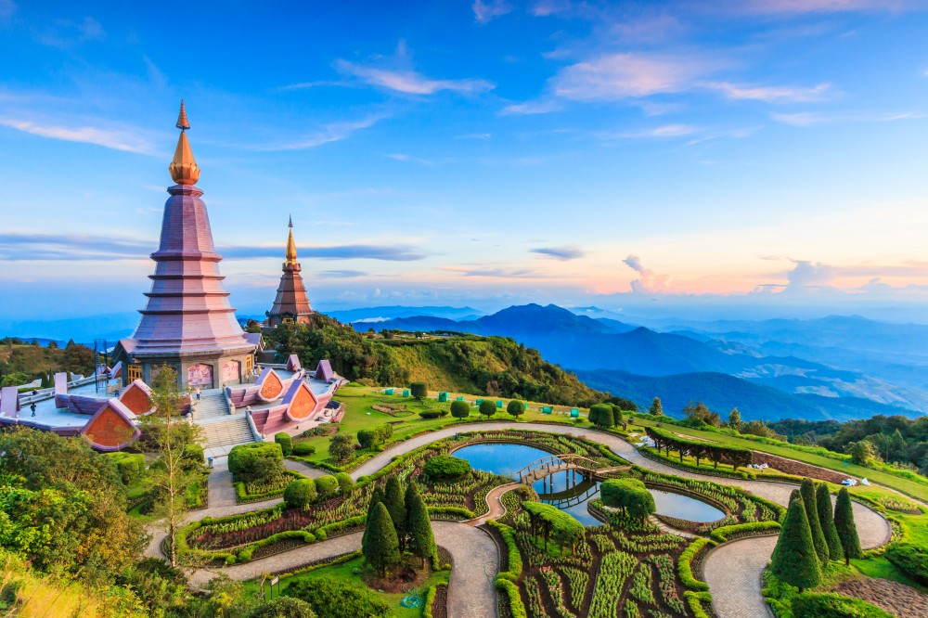
Doi Intenon National Park - The Highest Peak Of Thailand
08:30 a.m. – 04.00 p.m.
Visit to Doi Inthanon, the Thailand 's highest mountain
( 2565 meters above sea level), which offers beautiful scenery, evergreen mountain forests, dwarf rhododendron groves, rare bird life, and impressive waterfalls.
On this tour stops are made at: The Summit , containing the shrine of Chao Inthawitchayanon, the former prince of Chiang Mai. A short trek along Michael's Trail , a Canadian's volunteer who made an Exhibition in order for tourists visiting and to understand the nature and the environment and offers a beautiful and unforgettable experience. Then visit the great Twin Royal Pagodas , which were built for the highness Majesties of the King and the Queen. The place provides a marvelous view of surrounding.
Lunch serve at local restaurant.
Continue to visit Doi Inthanon Royal Project , one of many royal-sponsored reeducation projects initiated to familiarize hill tribe people with new agricultural techniques. Visitors can view the flower nurseries and cultivation areas. Continue to visit Karen Hill Tribe Villagefor an insight into their still primitive lifestyle. They are peaces loving warriors, very industrious and faithful people. On the way back see picturesque Vachirathan waterfall one of the highest waterfall in Northern Thailand . Then transfer back to hotel.

Included:
- Air-conditioned vehicles with experienced driver
- Service of English-speaking licensed guide
- Bottled drinking water during the tour
- Meals as mentioned in the program
- All entrance fees as mentioned in the program
Price exclude:
- Personal Expense
- Service charge 3.5% for paying by credit card charge
Full Day Tour | 1 | 2 | 3-5 | 6-8 | SIC
Doi Inthanon National Park | 5000 | 3000 | 2500 | 2000 | 1500
*PRICE AND ITINERARY ARE SUBJECT TO CHANGE WITHOUT PRIOR NOTICE*

