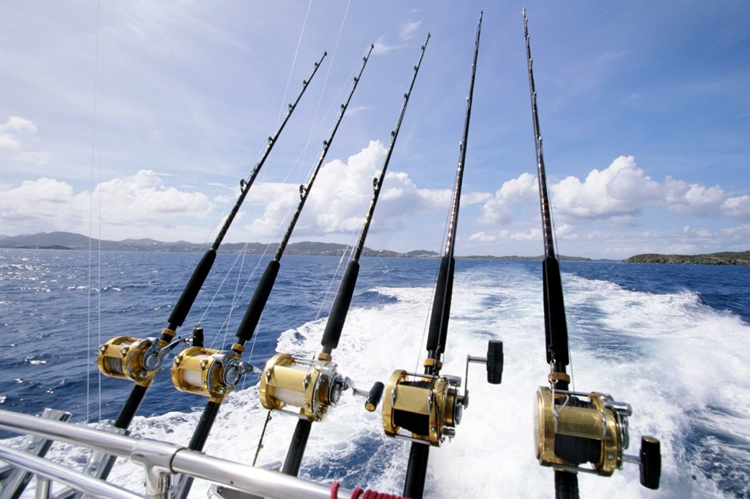
Duration 7 hours Every Day 1,700 Bath per person
Inc. lunch, fruit, soft drink, equipment set.

The day fishing tour
09:30 a.m. Pick up from hotel to Choengmon pier.
10:00 a.m. Departure to the first fishing area.
12:00 a.m. Lunch on the boat, mixed fruit & soft drink.
02:00 p.m. Sailing to the second fishing area.
05:00 p.m. Return to Choengmon pier and transfer back to hotel.
Night fishing tour
08:00 p.m. Departure from Choengmon pier to the fishing area first you will hunt squid with us that we later use as bait.
08:30 p.m. Search for a new fishing area.
02:00 a.m. Return to Choengmon pier and transfer back to hotel.
*PRICE AND ITINERARY ARE SUBJECT TO CHANGE WITHOUT PRIOR NOTICE*

