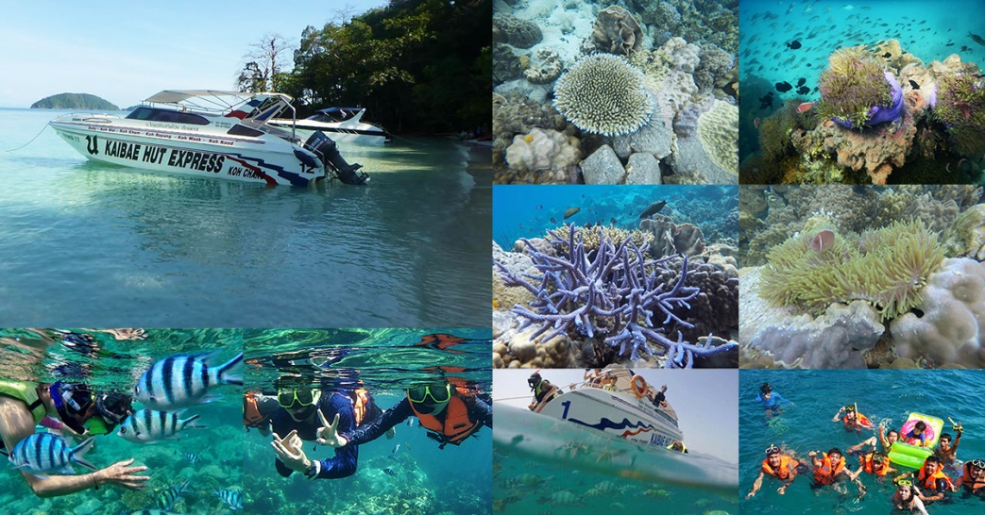
Koh Chang Package 2 Days 1 Night 5,200.-Baht / Per person
(Min. 2 Persons)

DAY 1
06.30 a.m. Depart from the resort Bangkok office by van.
12.00 a.m. Arrive at Koh Chang Resort & Spa Get welcome drink & check in Have lunch at the sunset seaside restaurant.
02.30 p.m. Take a trip to Klongplu Waterfall Evening dinner
DAY 2
07.00 a.m. Breakfast
09.00 a.m. Sightseeing and skin dive at Koh Yuak.
12.00 a.m. Have lunch and get ready for departure.
01.15 p.m. Departure from the resort.
About
07.30 p.m. Arrive at your hotel in Bangkok and farewell.

The Package Included :
- Transfer round trip: Bangkok - Resort - Bangkok
- Welcome drink
- 1 Night accommodation (twin sharing) +4 Meals
- 2 Activities
Exclusions:
- Optional tours or excursions not mentioned in the program
- Other meals not mentioned in the program
- Personal expenses
- Services change 3.5% pay by credit cards
Addition :
- Upgrade to deluxe with Jacuzzi type : 550 baht will be added.
- For The Squid Cashing (07.00 PM.-10.00 PM.) Only 390 Bath/Person (includes equipment + grill + water).
* PACKAGE PROGRAME IS SUBJECTED TO CHANGE WITHOUT PRIOR NOTICE *

