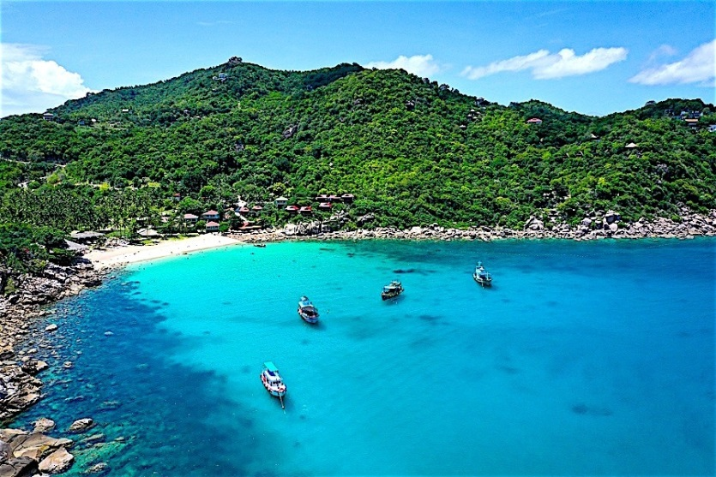
Snorkeling At Koh Tao And Koh Nangyuan (Speed Boat)

08:00 a.m. Pick up from the hotel by minibus
09:00 a.m. Speed boat leaves from Bophut pier
10:15 a.m. Arr. Koh Tao at Ao Pak Boong bay. Snorkeling around the beautiful coral reef with an abundance of marine life to see,
11:00 a.m. Leave for Koh Nang Yuan, visit Nang Yuan isle with joined sand-dune. the underwater visibility is about 10 to 30 mtrs. Depending on which side of the isle you are snorkeling on. Guests peaks of Nang Yuan isle
12:00 a.m. Lunch at Koh Tao Cottage restaurant will be a seafood feast cooked in a traditional Thai style setting.
01:00 p.m. Dep. for Muang bay relax or snorkel at a quiet beach and in 1 hour departure for Mea Had village. Take time to walk around and explore this small fishing village.
03:00 p.m. Dep. for Koh Samui, in 1:30 hour arr. Koh Samui at the pier, and transfer to hotel.
Duration 9 hours.
Include soft drink, snacks, snorkeling set, 1,700 Bht./per pax.
Extra Charge For Visiting Fee @ 100 Bht/Pax
Duration 9 hours. Include soft drink, snacks, snorkeling set, 1,700 B Bht/.per pax.
*PRICE AND ITINERARY ARE SUBJECT TO CHANGE WITHOUT PRIOR NOTICE*

