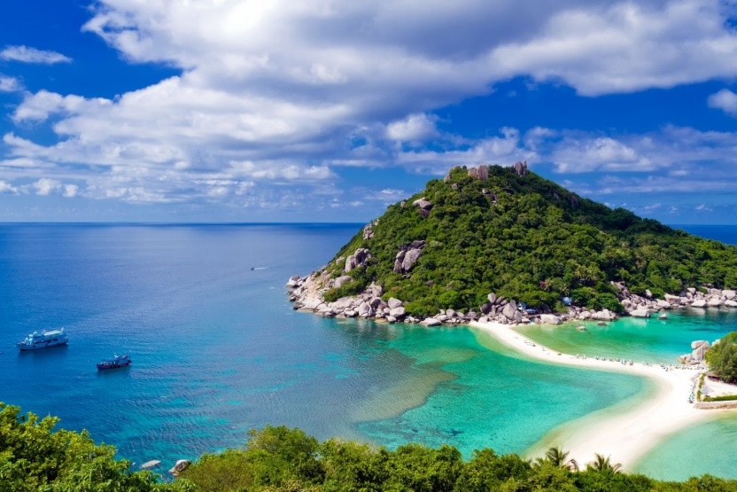
Day Trip Koh Phangan
Program on request ; Set duration 7 hrs 1,650 baht per person
Inc.R/T Trsf, Lunch, Frist aid, Snorkeling gear, insurance, English speaking Guide

07.30 a.m. Transfer from hotel to the pier
08.30 a.m. Depart from the pier to Thongsala pier Koh Phangan
09.00 a.m. Arr Tongsala pier and prepare to discover Koh Phangan by local taxi visit; Kuan Yin Shrine (Chinese Temple)
Snorkeling at Koh Mah, Lunch (Thai local cuisine), Chaloklum Fishing Village, Phaeng Waterfall National forest Park,
Wat Khao Tham (Meditation place), Wat Nai (Demon Stucco), Phangan biggest tree
04.00 p.m. Back to hotel by speed boat
*PRICE AND ITINERARY ARE SUBJECT TO CHANGE WITHOUT PRIOR NOTICE*

