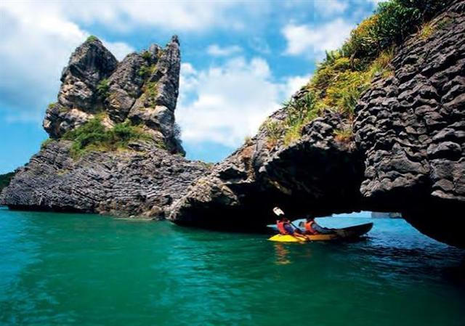
Kayaking at Angthong National Marine Park
Set duration 10hours every day.
2,190 baht per person included lunch, equipment, and round trip transfer
07:30 a.m. Pick up from hotel.
08:30 a.m. Depart from Big Budda pier to the Angthong National Marinr Park.
09:30 a.m. Arrive Marine Park and kayaking at Koh Samsao,Koh Tai Plas , or Koh Vow
( depens on the weather condition )
11:00 a.m. See wonderful Emerald Sea or Talay Nai
12:30 a.m. Go to Koh Wau Ta Lap, having lunch together.
01:30 p.m. Kayaking and spend your time on the beautiful white sand beach.
03:30 p.m. Depart from Marine Park.
04:30 p.m. Arrival Koh Samui and transfer to hotel.

*PRICE AND ITINERARY ARE SUBJECT TO CHANGE WITHOUT PRIOR NOTICE*

