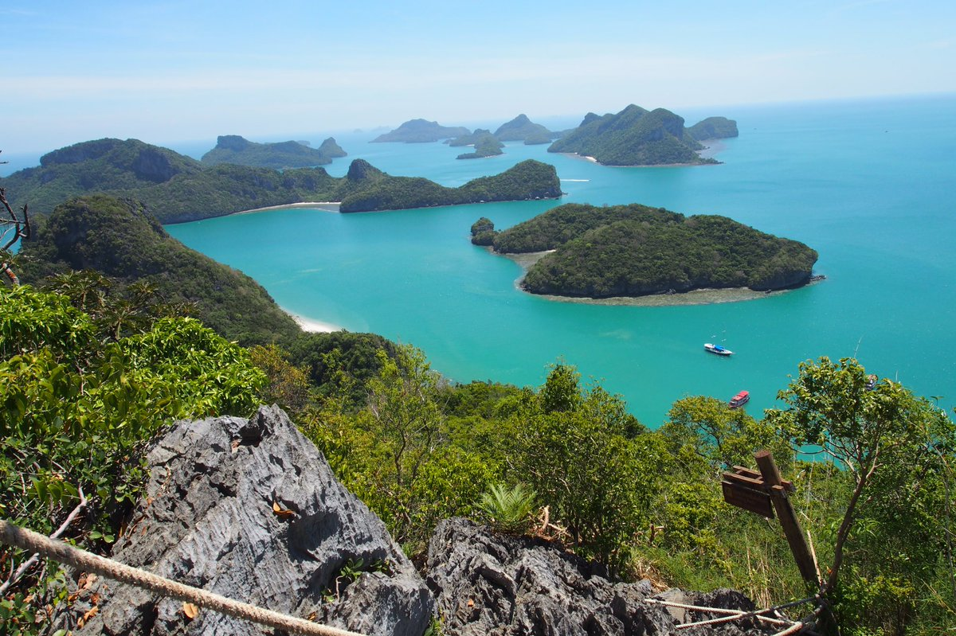
ANGTHONG NATIONAL MARINE PARK
Normal Boat 1,150 Baht per person Speed boat 1,700 Bath per person
07.30 a.m. Pick up from the hotel by minibus
08.30 a.m. Dep. from Bop hut pier by Cruise boat, coffee or tea served on the boat.
10.30 a.m. Arr. National Marine Park, Snorkeling here, visit the park office, the high viewpoint at Koh Wua Talap and stay at your leisure on the white sand beach you want to climb up to see the Bai-Bok Cave, feel free to do so!. We will have leisure time here about 2 hours.
01:00 p.m. Have lunch, Thai food buffet style on the boat, Then depart Koh Wuatalp to observe the surrouding view. The emerald salt water lake known as Talay Nai on Koh Mae Koh, stay at your leisure for snorkeling and sunbathing on the private beach, stop here 1:30 hour.
03:00 p.m. Leave from National Park to Koh Samui.
05:00 p.m. Arr. The Bop hut pier transfer to the hotel with happiness.

Duration 10 hrs departure hotel at 07:30 am
Normal Boat 1,150 Baht per person Speed boat 1,700 Bath per person
EXTRA CHARGE FOR VISITING FEE @ 200 BHT/PAX
*PRICE AND ITINERARY ARE SUBJECT TO CHANGE WITHOUT PRIOR NOTICE*

