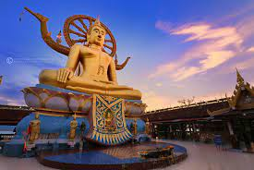
Around Samui Island (Full day)
Set duration 7 hrs, 1,400 Baht per person, minimum 2 pax

Pick up from the hotel by minibus. The first stop at Island Safari to see the Monkey and Baby Elephant show, after that visit Chaweng view point the panorama view of Chaweng beach and the crystal blue sea. Then visit the strange rock formation called “HinTa HinYai” in Thai, or “Grand Pa and Grand Ma rocks”, after that visit Kunaram temple to see the Mummy Monk, and visit the natural waterfall at Namuang no.1, it's impressive with a wild drop of 30 meters. After fifteen(15) minutes, We will go to Tong Krut Restaurant for have lunch about 1 hr and after that, we will depart to Nathon town for shopping. The last stop at the Big Buddha temple, seated on a hillock. Back to hotel.

Departure Every day 09:00 AM
set duration 7 hrs, 1,400 Baht per person, minimum 2 pax. Inc. Lunch
Private 1,500 bht Inc. English speaking guide
Maximum 2 pax, Inc. Lunch

*PRICE AND ITINERARY ARE SUBJECT TO CHANGE WITHOUT PRIOR NOTICE*

