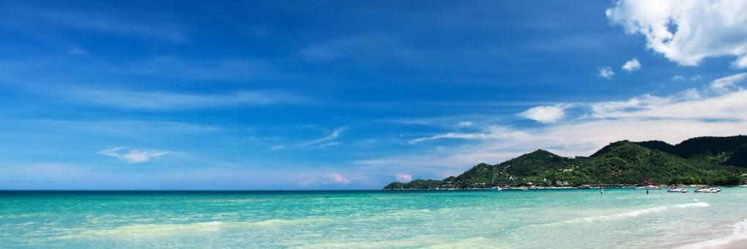
AROUND SAMUI ISLAND (HALF DAY)
Set duration 5 hrs, 750 Baht per person, minimum 2 pax.
Private 1,800 bht Inc.English speaking guide
Maximum 2 pax.
Pick up from the hotel by minibus.The first stop at Chaweng view point the panorama view of Chaweng beach and crystal blue sea. After that visit the strange rock formation called “HinTa HinYai” in Thai, or “Grand Pa and Grand Ma rocks” in English.
Then visit Kunaram temple to see the Mummy Monk, and visit the natural waterfall at Namuang no.1, it's impressive with a wild drop of 30 meters. After fifteen (15) minutes, we will depart to Nathon town for shopping.The last stop at the Big Buddha temple, seated on a hillock. Back to hotel.
Departure Every day 09:00 AM
Set duration 5 hrs, 750 Baht per person, minimum 2 pax.
Private 1,800 bht Inc. English speaking guide Maximum 2 pax
*PRICE AND ITINERARY ARE SUBJECT TO CHANGE WITHOUT PRIOR NOTICE*

