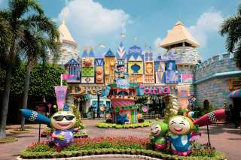
Dream World
(Baht 1,200.- / Per person)
08.00 a.m. Pick up from the hotel
09.30 a.m. Arrive Dream World where you will experience spectacular atmosphere, enjoy its four lands of dream
12.00 a.m. International buffet lunch
01.00 a.m. Enjoy riding The Vikingsship Bumpcar , Ufo , Thunder birds wingchair , Bump Boat , Monorall , Super Splash , Indian Boat , Flying Caroet , Rapter , Viking , Hanging Coaster and so on you will have the fun in the dream world
03.00 a.m. Leave for Bangkok
04.00 a.m. Return to the hotel
Price Exclude :
Personal Expense :
- Service charge 3.5% for paying by credit card charge
*PRICE AND ITINERARY ARE SUBJECT TO CHANGE WITHOUT PRIOR NOTICE*

