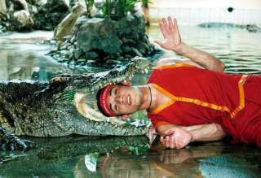
Sampran Crocodile Farm (Baht 900.- / Per person)

11.00-12.00 a.m. Pick up from the hotel
Sampran Crocodile Farm + Elephant Show
Enjoy a spectacular show of Crocodile Wrestling between man and crocodiles are also offers. The farm of more than 10,000 crocodiles is acclaimed to have one of the cleanest and most impressive public crocodile displays in the world. (by CITES)
Enjoy he Magic Show, then see the Greatest Elephant Show in Thailand, an elephant show complete with dramatic sounds and narration Watch a ceremonial rite to bless the buffalo hide cord before hunting the elephants. Be entertained to football jumbo cup, dancing and at play from well-trained cutes. And re-enacting Yutha Hathi, an ancient battle scene on elephant back in full battle gear.
17.30 Return to the hotel

Price Exclude :
Personal Expense :
- Service charge 3.5% for paying by credit card charge
*PRICE AND ITINERARY ARE SUBJECT TO CHANGE WITHOUT PRIOR NOTICE*

