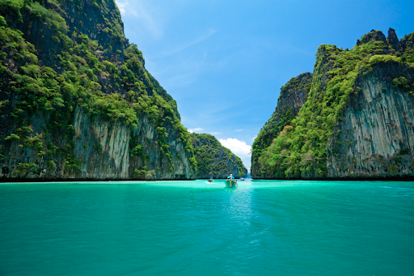
Phi Phi Islands Tour by Speedboat (Ratsada Pier)
(Adult 16,00.- Baht / Person Child 1,200.- Baht / Person)
Phi Phi is one of the world's wonders - a beautiful lushly-green tropical islands set in a turquoise sea. Travel from Ratsada Pier by speedboat to explore this wonderland, taking in white-sand beaches, crystal-clear waters and the best of this area's sights.

Itinerary :
07.30 - 08.00 a.m. We will pick you up from your hotel and take to Ratsada Pier.
09.00 a.m. Leave from the Pier and go to Phi Phi Island.
09.50 a.m. Enjoy snorkeling at the lovely white sand beach at Yong Kasem (Monkey Beach) and explore the many delights at Camel Rock (Nui Bay) and its beautiful scenery.
10.30 a.m. Arrive at Phi Phi Lay and get to know the unique landscape of Maya Bay (Made famous from the movie "The Beach"). It’s up to you to try snorkeling the beautiful reefs or simply relaxing on the beach with a cool drink. Discover the hidden delights Loh Samah Bay, Pileh Lagoon and Viking Cave.
12.30 a.m. Enjoy a sumptuous lunch at a beachside restaurant on Phi Phi Don. After lunch spend your time relaxing on the beach or engage in sea sport activities.
04.30 p.m. Arrive back to Ratsada Pier and proceed back to your hotel.

Tour Price included :
- Hotel transfers, English speaking guide, speedboat trip and entry fees to the national park.
- On board: soft drinks, water, ice and fresh fruits
- Lunch: meal, drinking water, coffee and tea
- Full snorkeling equipment: lifejacket, mask and snorkel
- All safety equipment and insurance are provided
Price exclude:
- Personal Expense
- Service charge 3.5% for paying by credit card charge

*PRICE AND ITINERARY ARE SUBJECT TO CHANGE WITHOUT PRIOR NOTICE*

