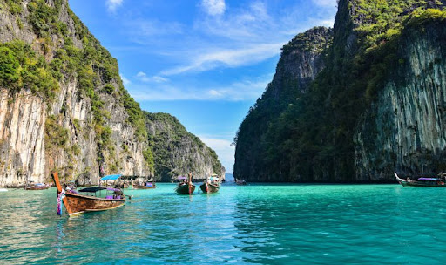
Krabi One Day Trip To Phi Phi Island
( Adult 1,700 Baht/Person Child 850 Baht/Person )

Time: 08.30 am. – 04.00 pm.
- 08:30 a.m. : Start from Klong Dao Beach .And pick up guests from other beach (pick up by speed boat)
- 09:30 a.m. : Arrive at Phi Phi Don and bring the guests to view point or if you don’t like trekking you may stay on the island and walk around.
- 11:30 a.m. : Stop at Bamboo Island, you may relax on the beach for sun bathing, walking around the island or snorkeling near the beach.
- 12.30 a.m. : Lunch on the beach.
- 01:30 p.m. : Set for the last stop, and it the best spot of the trip. Visit Maya Bay where the movie The Beach was taken here. And sightseeing around Phi Phi Ley taking photo and snorkeling.
- 03:00 p.m. : Depart from Phi Phi Ley and back to Koh Lanta.
- 04:00 p.m. : Arrive Koh Lanta.
Tour Itinerary
Tour include : Snorkel, mask & fin, lunch, soft drink, drinking water, fruits and National park fee.
Exclusions :
- Optional tours or excursions not mentioned in the program
- Other meals not mentioned in the program
- Personal expenses
- Services change 3.5% pay by credit cards
*PRICE AND ITINERARY ARE SUBJECT TO CHANGE WITHOUT PRIOR NOTICE*

