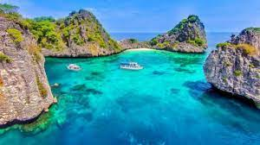

Krabi One Day Trip To Koh Rok
( Adult 1,700 Baht/Person Child 850 Baht/person )

Time: 08.30 am. – 04.00 pm
08:30 a.m. : the boat Start from Klong Dao Beach .And pick up guests from other beach (pick up by speed boat)
10:00 a.m. : Arrive at Koh Rok and start snorkeling from the boat for 1 hour.
11:30 a.m. : Stop on the island, you may relax on the beach for sun bathing, walking around the island or snorkeling near the beach.
12:30 a.m. : Lunch on the beach.
01:30 p.m. : Set for the last stop, and it the best spot for snorkeling of the trip.
03:00 p.m. : Depart from Koh Rok and back to Koh Lanta.
04:00 p.m. : Arrive Koh Lanta.
Tour Itinerary
Tour include : Snorkel, mask & fin, lunch, soft drink, drinking water, fruits and
National park fee.
Exclusions :
- Optional tours or excursions not mentioned in the program
- Other meals not mentioned in the program
- Personal expenses
- Services change 3.5% pay by credit cards
*PRICE AND ITINERARY ARE SUBJECT TO CHANGE WITHOUT PRIOR NOTICE*

