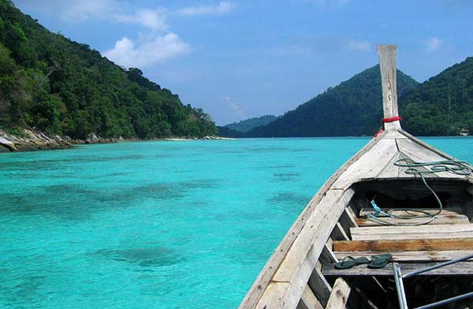
One Day Trip To Surin Island
( Adult 3,800 Baht/Person Child 2,300 Baht/Person)

06.00-07.00 am Pick up from hotel to Baan Nam Kem Pier
09.00 am. Depart to Surin Island by speed boat
10.30 am. Arrive at one of the reefs for your first snorkeling of the day at the South Island
12.00 pm. Enjoy Lunch in the cafeteria provide by the national park on the beautiful north island then get relax on the beach
01.15 pm. Get back to the speed boat for the second reef to snorkel on the way passing the word of moken village "The sea gypsies" to see the traditional village on these Islands then we’ll take you to the third reef the last one of the fantastic day.
03.15 pm. Depart Surin Island after an amazing day.
04.45 pm. Arrive at Baan Nam Kem pier and transfer back to hotel.

Tour Itinerary
Tour Include : Tour guide ,lunch ,soft drink, hotel transfer ,insurance ,snorkeling equipment.

Exclusions :
- Optional tours or excursions not mentioned in the program
- Other meals not mentioned in the program
- Personal expenses
- Services change 3.5% pay by credit cards
Remark :
- Operate high season only
- This program is subject to change according to the weather and sea conditions
*PRICE AND ITINERARY ARE SUBJECT TO CHANGE WITHOUT PRIOR NOTICE*

