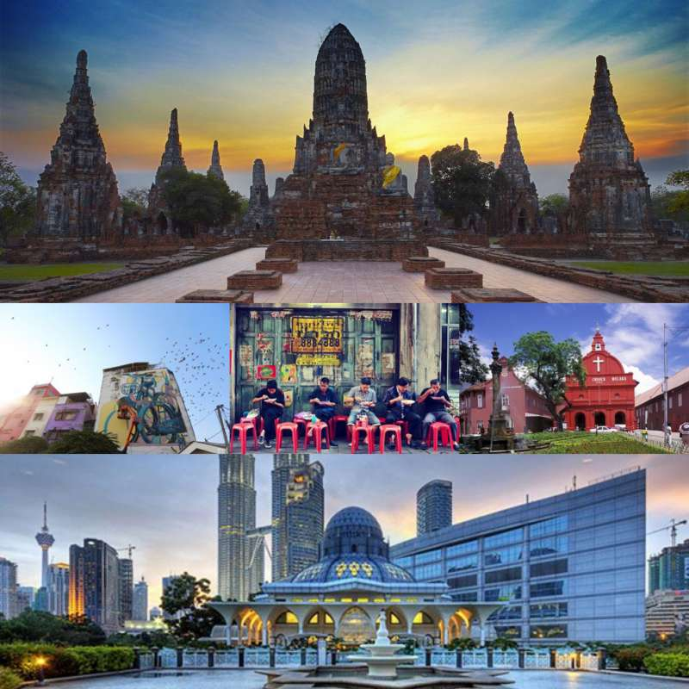
Experience Thailand and MORE to ASEAN Gastronomy Local Experience

The idea is to showcase Thailand-Malaysia under the concept “ASEAN Gastronomy Local Experience”
for travel agents to touch and feel the authentic Thailand experience and MORE.

Highlights
Thailand – Bangkok – Ayutthaya – Malaysia – Malacca – Kuala Lumpur

Day 1
08.30 a.m. Pick up from your hotel.
09.00 a.m. Take the Historic Bangrak Food & Culture Walks to explore Bangrak legendary eats which is the area to showcase the cultural mixes to try the melting pot foodie experience and get to know Charoenkrung.
This morning you will head to Bangrak for your Historic Bangrak Food & Culture Walk tour. Bangrak is the district famous among Thais for its diverse local flavors. The area is a true melting pot, where you can find Thai delicacies from various regions and ethnicities. As we journey along our easy-to-walk route, you will meet and engage with restaurant owners, sample their generations-old artisanal recipes, and visit fascinating local attractions hidden away from major tourist path. Not only you will get full exposure to the Thai gastronomic tradition but your visit will also be a great support to local community.
10.30 a.m. Then head to Ayutthaya, located 48 miles north of Bangkok.
11.30 a.m. Visit Ayutthaya’s Historical Exhibition Hall to gain more knowledge about the origin of Ayutthaya and traditional Thai food.
12.30 a.m. Continue to your restaurant for lunch.
01.00 p.m. Enjoy your lunch at Usman Steakhouse where Thai cuisines are prepared for the guests. Observe or even participate in the cooking process.
02.00 p.m. Continue to Wat Phanan Choeng.
02.30 p.m. Pay a visit and explore the great beauty of Wat Phanan Choeng.
Located on the bank of the Pa Sak River, this temple houses an enormous seated Buddha image considered one of the most beautiful in Thailand. According to the legend, tears shed from the eyes of the image just before the destruction of Ayutthaya by the Burmese in 1767.
The 19 m tall Buddha image, named Phra Chao Phanan Choeng is seated in the posture of subduing Mara, also known as calling the Earth to witness. This “Luang Pho to” as another name is a richly gilded U Thong style image, built in 1324, several decades before Ayutthaya was founded. It is enshrined in a large viharn which was later built. It was said that the temple was built by a king as a cremation site for his fiancée Princess Soi Dok Mak who waited for him for so long there and killed herself.
03.30 p.m. Stop by at the souvenir shop of Ayutthaya to have a taste of the famous Thai dessert, cotton candy wrapped in sweet roti (Roti Sai Mai), and learn its cooking process
04.15 p.m. Continue to your hotel for check-in.
04.45 p.m. Check-in at your hotel. Enjoy the evening at leisure.
06.00 p.m. Enjoy the fantastic special dish of Ayutthaya – grilled prawn with Thai-styled sauce, with delicious dinner at a local restaurant – Taak Mork Restaurant.
Evening Overnight at your resort.
Meals included: Breakfast, Lunch, Dinner
Accommodation: Ayodhara Village

Day 2
08.00 a.m. Breakfast at your hotel.
09.00 a.m. Check out and leave the hotel to visit the peaceful scenery of Ayutthaya Historical Park, a place listed as UNESCO World Heritage Site.
09.30 a.m. Explore today the Ancient Capital of Ayutthaya. Step back into the days when Thailand was Siam as you visit the unforgettable beauty of Ayutthaya—a UNESCO World Heritage Site.
Ayutthaya was a former capital of Thailand during 1350-1767 A.D. was once the center of the Kingdom, today only the ruins of this magnificent city remain. It was a truly fabulous kingdom for 417 years and built on what Sukhothai had begun and carried onward with remarkable flair and panache. It also set the standards for Bangkok to follow. At the magnificent city ruins, you can see Wat Phra Sri Sanpetch with three-spired pagoda, the large Buddha image of Phra Mongkol Bophit and then visit to Wat Chaiya Mongkol and the striking monastery of Wat Chai Watanaram, and also Wat Mhathat as one of Ayutthaya’s oldest temples. Don’t miss the Buddha in a Bodhi tree.
12.00 a.m. Lunch at Krua Pak Wan.
01.00 a.m. Travel to Bang Pa In district.
01.45 p.m. Visit Bang Pa-In Summer Palace of King Rama V, consisting of buildings in a quaint mixture of European, Thai and Chinese architecture, a well-preserved “monument” to a former historical period. Visit also Wehat Chamrun Palace to be marvelled to its Chinese interior decor.
03.30 p.m. Return to Bangkok.
05.00 p.m. Check-in at your hotel and enjoy the late afternoon at leisure.
07.00 p.m. Later this evening, enjoy Bangkok Night Light tour.
The ubiquitous Tuk Tuk is synonymous with Bangkok, forming a part of everyday life for many of its residents and certainly a mode of transport every visitor must experience at least once. The tuk tuk, named after the sound its two-cycle engine & Up makes, are a fast and efficient way to travel in congested areas where they can weave around stationary cars. Their flashing on-board lights and ornate Thai metalwork also add a sense of excitement. Tour is suitable for a minimum of two and maximum of 10 people – taking guests on an eye-opening tour of Bangkok's famed sights after the sun goes down. Often overlooked at night, the capital's magnificent temples take on a whole new perspective as we approach by moonlight. Also on our agenda are stops at the vibrant flower market that carries on late into the night and the opportunity to visit a selection of scrumptious street-side food stalls.
Return to your hotel for a good night sleep.
09.00 p.m. Overnight at your hotel.
Meals included: Breakfast, Lunch, Dinner on tour
Accommodation: Chatrium Riverside Hotel

Day 3
05.00 a.m. You will be transferred to Don Muang International Airport for your flight to Kuala Lumpur on AK 891 DMK-KUL 08.35 a.m. - 11.50 a.m.
08.35 a.m. Travel to Kuala Lumpur International Airport (KLIA), Malaysia with Air Asia. Flight AK891. Breakfast onboard is included.
11.50 a.m. Arrive Safely at KLIA. Go through the Immigration and then travel by road to Malacca by 2 vans.
03.00 p.m. Enjoy lunch at Ee Ji Ban Chicken Rice Ball (Halal Restaurant for lunch).
04.30 p.m. Visit Dutch Square, St. Paul Church. If time permits, visit baba & nyonya Heritage Museam.
Visit St. Peter’s Church (1710) – the oldest Christian Church still in use in Malaysia. Proceed to view the famous gateway. “Port De Santiago” and the ruins of St. Paul’s Church lined by 17th century Dutch tombstones. Next on the list is “Red Square” – the salmon pink Dutch administrative building which today house the Malacca Museum and government offices. Visit Christchurch before proceed for lunch, we visit the “Abode Merciful Clouds’ or the Cheng Hoon Teng Temple – the only temple where you can find 3 major doctrines of local Chinese belief under the same roof, viz – Taoism, Buddhism and Confucianism. Take a stroll along Malacca’s Jonker Street
05.30 p.m. Take break at Calanthe Art Café, the famous coffee that brings coffee from all 13 Malaysian states.
LATE AFTERNOON Then check in at your hotel.
08.00 p.m. Meet up and proceed to Restaurant Ole Sayang for traditional Peranakan Cuisine.
After dinner, drop off at hotel. Free at leisure.
Note :
- All the restaurant mention above is local managed restaurant and comes with standard services.
- Since most of the agents are Middle East, halal chicken rice shop is chosen.
Baba & Nyonya Heritage Musuem closed at 04.00 p.m. . Should time permits we will proceed for the visit.
10.00 p.m. Overnight at your hotel.
Meals included: Breakfast, Lunch, Dinner
Accommodation: Hotel Puri Malaccao (Superior Room)

Day 4
Morning Breakfast at your hotel.
08.30 a.m. Check-out of your hotel and you will be transferred overland to Kuala Lumpur.
10.30 a.m. The Kuala Lumpur Tour is the best way to explore the city’s most interesting sightseeing attractions. A must for first time visitors to Kuala Lumpur. An interesting tour which unveils the beauty and charm of the old and new Kuala Lumpur. Garden City of Lights. See the contrast of the magnificent skyscrapers and the building of the colonial days.
Highlight Of The visit:
- Petronas Twin Tower & KLCC Park (photo stop)
- National Monument
- National Mosque (photo stop)
01.30 p.m. Proceed to FIERCE curry house for your Indian cuisine lunch. Some free at leisure.
03.00 p.m. Proceed to Kuala Lumpur International Airport 2 for your flight to Bangkok on AK 888 KUL-DMK 06.35 p.m. - 07.50 p.m.
06.35 p.m. Depart for Bangkok on AK 888, operated by Air Asia. Dinner onboard is included.
07.50 p.m. Arrive safely at arrival at Don Muang International Airport.
Meals included: Breakfast, Lunch
Accommodation: None
******

