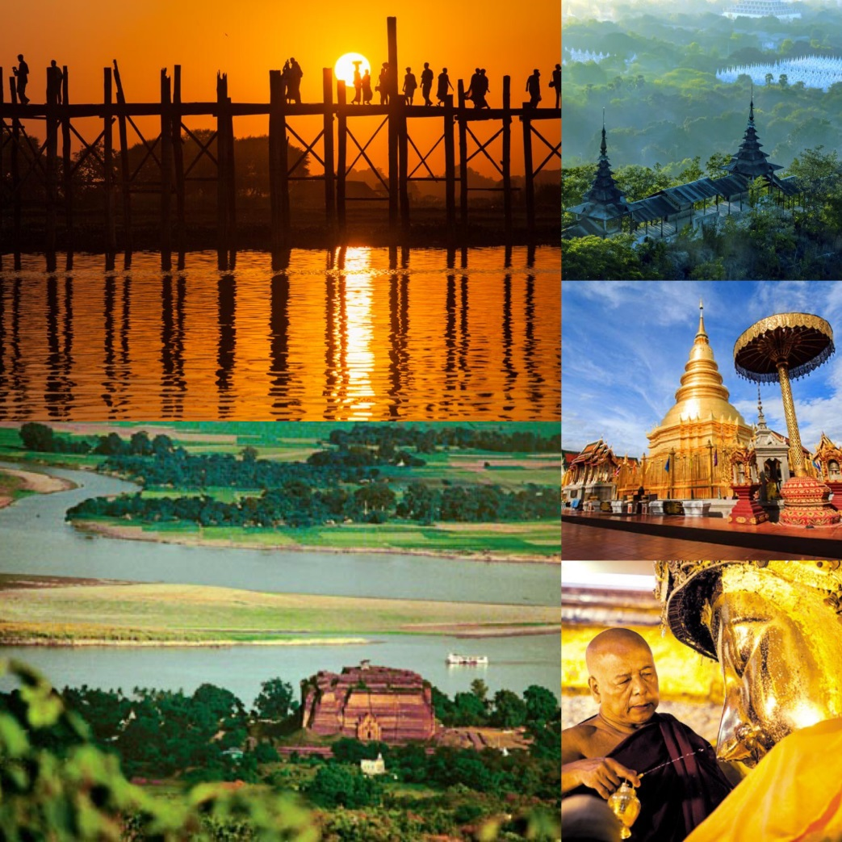

Experience Thailand and MORE to ASEAN Kingdoms Journey

The idea is to showcase Thailand-Myanmar under the concept “A Journey of ASEAN Ancient Kingdoms”
for travel agents to touch and feel the authentic Thailand experience and MORE.

Highlights
Thailand – Bangkok – Chiang Mai – Lamphun – Myanmar – Mandalay

Day 1
06.00 a.m. You will be picked up and transferred to Bangkok Suvaranbhumi Airport for your flight to Chiang Mai.heck in at Suvarnabhumi Airport
06.45 a.m. Check-in on PG 215 BKK-CNX 08.05 a.m. – 09.20 a.m. (operated by Bangkok Airways)
08.05 a.m. Depart for Chiang Mai, Flight PG215 operated by Bangkok Airways.
09.20 a.m. Arrival at Chiang Mai Airport. Transfer to Lamphun
10.45 a.m. Arrive Lamphun and Visit Wat Phra That Hariphunchai, Wat Cham Thewi and Institute of Hariphunchai Hand-woven Fabric.
Lamphun is an ancient town by the Ping River. Retaining its old-world charm, Lamphun was founded as the city of Haripunjaya, a Mon kingdom-city, arguably part of the Dvaravati civilization, established in the ninth (perhaps seventh) century by former Buddhist monks from Lopburi. Haripunjaya was first ruled by Queen Camadevi, daughter of the king of Lopburi, who established a legacy for the province’s reputation for beautiful women. The kingdom she ruled over thrived for several centuries, exerting wide influence across the region, before King Meng Rai used subterfuge to conquer the town in late 12th century and integrate it into the Lan Na Kingdom based in nearby Chiang Mai.
Today, Lamphun still retains the enchanting ambience of a small but old community, where life moves at a leisurely pace and remnants of the city’s fortifications remind visitors of the city’s proud history. Lamphun is some 670 kilometers from Bangkok and only 26 kilometers from Chiang Mai. Located on the banks of the Kuang River, Lamphun features a skyline made of temple spires and attractions across the province include ancient sites as well as forests, mountains, and lakes.
Your first stop is at one of the must-see in Lamphun - Wat Phra That Hriphunchai.
Wat Phra That Hriphunchai’s a principal landmark is the 46-metre tall golden chedi with its present appearance as a result of the restoration work in 1443 by a king of Chiang Mai. It is covered with copper plates and topped with a multi tiered golden umbrella weighing 6½ kilos. The 46 meter high chedi encases a much smaller 9th century Mon stupa. The chedi sits inside a square fenced space, not accessible to visitors. The gilded parasols at each of its four corners were added early 19th century. Other architectural works include Ho Trai or library – in elegant teak structure with multi tiered roof and intricately carved doors - where the ancient Buddhist scriptures are kept.
Continue to Wat Cham Dewi. Wat Chama Devi or Wat Ku Kut was founded by Queen Chama Devi, a daughter of a king in Lavo or Lopburi Kingdom. She was sent to the north to establish the new kingdom of Hariphunchai and was the founder and the first ruler in the 7th century AD
Hariphunchai was regarded as the first civilization in the North and was an important Centre of Theravada Buddhism. It had a thriving artistic and cultural scene and engaged in trade with major kingdoms such as the Khmer and Chinese empires, as well as with Lavo.
Her dynasty lasted until the middle of the 11th century when Phraya Mengrai, founder of Chiang Rai and Chiang Mai, invaded the kingdom in the 13th century. Hariphunchai became part of Lanna which was fully absorbed into Siam in the late 19th century.
Wat Chamma Dewi is the final resting place of Queen Chamma Thewi. Her cremated remains have been housed in Chedi Suwan Chang Kot or Chedi Ku Kut, its former name. Carved into the four side of the Mon-architectural style pagoda are 60 images of standing Buddhas, which reflect the arts of Hariphunchai -- a square face, big eyes, connected eyebrows and pencil moustache.
Then visit the Institute of Hariphunchai Hand-Woven Fabric. Lamphun is famous for its hand-woven silk brocades called in Thai Pha Mai Yok Dok, with lustrous and exceptional beauty. Pha Mai Yok Dok is a high-class hand-woven silk. In the past, this kind of woven silk was used by noblemen only while hand-woven cotton was used among the middle-class people. Princess Dara Rasmi, one of the princess consorts of King Rama V of Chakri Dynasty, originally from Chiang Mai Dynasty, after the passing of King Rama V, returned Chiang Mai and passed down the technique from the royal court through HH’s relatives of Lamphun Governor at that time.
The institute features a weaving hall, a small museum with a collection of old Lanna designs and a gallery/shop. Each weaving cloth has a QR code on its price tag allowing buyers to learn who weaves the cloth. The information also.
12.45 a.m. Transfer to visit Ban Nong Nguek Community and Wat Nong Nguek (Ampher Pasang).
01.30 p.m. Late lunch at Krua Pa Sang Restaurant (Northern food style)
02.30 p.m. Visit also Baan Nong Nguek Community in Pasang. Handicrafts including hand-woven cotton fabrics which are produced in every district. This is an additional job for inhabitants when they are free from agricultural works. And Baan Nong Nguek is the most famous district for hand-woven fabrics. Hand-woven cotton fabrics appear in many shapes and forms. There are sheets which can be used to make sarongs and ready-made clothes as well as other household tools and equipment for instance tablecloth, coasters and plate mat etc. With regard to the distribution of hand-woven fabrics and products, they are distributed mainly to large markets such as Bangkok and Chiangmai.
Take this opportunity to visit Wat Nong Nguek, a community temple built in 1828. Admire its Ubosot built in applied Lanna architectural style. Ho Trai is also gorgeous in Mon-European and local architectural style. Inside is a mural painting of the Lord Buddha when He was still a Buddhist Saint. Another important building in the temple is the stupa that house an emerald Buddha image and 101 Buddha relics.
04.30 p.m. Transfer back to Chiang Mai and check in at hotel.
06.30 p.m. Depart from hotel to Chiang Mai Foodie Tour and Chaing Mai Street Food Tour.
As the former capital of the Lanna Kingdom; the second-oldest Thai Kingdom after the Sukhothai Kingdom, Chiang Mai became a vital cultural and commercial crossroads city between Thailand, Myanmar (Burma), Laos and China. The first Thai culinary recipes, as identified by many ingredients that are still in use today such as lemongrass and galangal, have their roots in culinary use in the north and were perfected in the Chiang Mai royal courts. This evening tour provides an insight into the culinary heritage of the “Rose of the North”. You will embark on a guided tour, where you will sample the delights of Chiang Mai cuisine, including various mouthwatering local snacks, and the delicious Khao Soi – a delicious coconut curry noodle dish that is unique to Chiang Mai. After the tour, you may wish to go to the night market, where your guide will assist you should you want some help with bartering, or searching for particular items
09.30 p.m. Stay overnight at Siripanna Villa Resort & Spa.
Meals included: Lunch, Dinner on the tour
Accommodation: Siripanna Villa Resort & Spa

Day 2
Morning Breakfast at your hotel.
08.15 a.m. Head on to Studio Naenna for a fun day with hand-on Indigo Workshop. The studio supports weavers for the environment in the production of exquisite and eco-friendly garments, accessories and textiles.
09.00 a.m. Studio Naenna isfounded by Patricia Cheesman, an expert in antique Lao and Thai textiles and lecturer in Thai textiles, ceramics and contemporary design at Chiang Mai University. The studio supports weavers for the environment in the production of exquisite and eco-friendly garments, accessories and textiles. Take this chance to participate in hands-on workshop at the studio to engage others and share an appreciation for an exceptional, sustainable and enduring art form. Learn the theory of natural dyes and tie dye techniques and start your indigo dyeing and take home your master piece!
You will have a chance to visit the two galleries where there is a large variety of high quality garments in western sizes for sale and exquisite interior design textiles or antiques from Patricia’s private collection (depending on the display at the time).
12.30 a.m. Lunch at a local restaurant
01.30 p.m. Transfer to Chiang Mai Airport for your flight to Mandalay on PG 725 CNX-DML 04.15 p.m. - 05.20 p.m.
04.15 p.m. Depart on PG 725, operated by Bangkok Airways.
05.20 p.m. The last capital of the third Myanmar Empire, Mandalay is situated in the Centre of the country, some 668 km due north of Yangon. It is the largest city after Yangon and is both a bustling commercial Centre and a repository of ancient culture.
With the remains of the old Royal City, sacred monasteries and numerous other places of interest, Mandalay is a showcase for Myanmar art and architecture and is known as the country’s cultural capital. It is also noted for woodcarvings, silverware, tapestries, silk cloth, and other traditional craft products
On arrival at Mandalay Airport, you will be transferred for dinner at Unique Myanmar Restaurant.
Night After dinner, you will be transferred to your hotel for check-in. The rest of the day is at your leisure.
Meals included: Breakfast, Lunch, Dinner
Accommodation: Mandalay Hill Resort Hotel (Deluxe room)

Day 3
04.30 a.m. Witness the morning face-washing ceremony of the Mahumani Buddha, the most revered image in Mandalay.
Morning Breakfast at your hotel.
08.00 a.m. Depart from Hotel to jetty for 1- hour cruise across the mighty Ayeyarwaddy River (Irrawaddy) to the quaint village of MINGUN and Visit Mya Thein Tan Pagoda
Visit Ancient Mingun is located on the western bank of the Ayeyarwaddy River and is famous for its huge, unfinished stupa as well as its impressive bronze bell which was commissioned by King Bodawpaya in 1808 and weighs in the region of 90 tons. Reaching the site is part of the enjoyment as you journey by boat (approximately one hour) to get there and return via the back lanes passing picturesque villages along the way.
Noon Lunch at BBB restaurant.
Afternoon Visit Gold Leaf Beating workshop afterward and view artisans making thin leaves of gold leaf used for offerings.
Continue to the Shwenandaw Kyaung (Golden Palace Monastery), an imposing teak monastery-temple that was originally built within the palace complex but subsequently dismantled and rebuilt some years later.
Continue to Kuthodaw Pagoda which is said to house the world’s largest book on account of the 729 marble slabs that are inscribed with Buddhist scriptures.
Finish the day with a drive to the top of Mandalay Hill for sunset and a panoramic view of the city.
Evening Dinner at Bistro 82 restaurant.
Night Stay overnight at Mandalay Hill Resort Hotel (Superior Room)
Meals included: Breakfast, Lunch, Dinner
Accommodation: Mandalay Hill Resort Hotel (Deluxe room)

Day 4
07.00 a.m. Breakfast at your hotel.
08.00 a.m. Depart to visit silk weaving workshop.
Continue to explore Amarapura where was Myanmar’s penultimate Royal Capital, the iconic U Bien’s Bridge, which spans Taungthaman Lake and is the longest teak footbridge in the world
Meaning ‘City of Immortality’, Amarapura was Myanmar’s penultimate Royal Capital and the last stop today before returning to Mandalay. Sightseeing will include the iconic U Bien’s Bridge, which spans Taungthaman Lake and is the longest teak footbridge in the world. It is often busy with locals ‘commuting’ back and forth which makes for an attractive photo opportunity.
Continue to Mahagandayon Monastery and there will be also observed 1000 or so monks having their main meal for the day at Monastery, they are prohibited to take any food after midday.
11.00 a.m. You will be transferred to Mandalay airport for your flight to Bangkok on PG 710 MDL-BKK 02.05 p.m. -04.30 p.m.
02.05 p.m. Depart for Bangkok on PG 710, operated by Bangkok Airways
04.30 p.m. Arrival at Bangkok Suvarnabhumi Airport.
Meals included: Breakfast
Accommodation: None
*****

