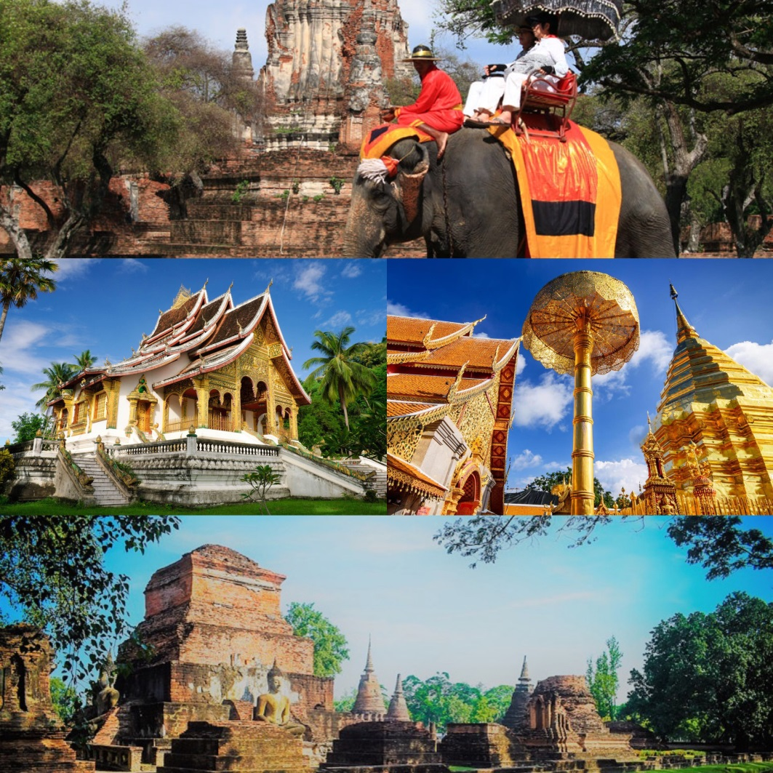

Experience Thailand and MORE to ASEAN World Heritage Cities

The idea is to showcase Thailand-Laos under the concept “A Journey of ASEAN Heritage Cities”
for travel agents to touch and feel the authentic Thailand experience and More.

Highlights
Thailand – Bangkok – Sukhothai – Chiang Mai – Laos – Luang Prabang

Day 1
05.00 a.m. Depart for Sukhothai, Flight PG 211 BKK-THS 07.00 a.m. - 08.15 a.m. operated by Bangkok Airways.
Sukhothai was the first independent kingdom of Thailand, founded in 1238. Literally, Sukhothai means Dawn of Happiness. As a result it now offers a myriad of sightseeing opportunities close at hand and also a little further afield. The superb temples and monuments of this great city have been lovingly restored in Sukhothai Historical Park, a UNESCO World Heritage Site and a must-see for all travelers.
08.15 a.m. Arrive in Sukhothai and head Organic Agriculture Project where is traditional rice-growing techniques are still maintained, including the use of water buffalo to plough the paddies.
12.00 a.m. Lunch at Krua Sukho Restaurant.
01.00 p.m. Then continue to Sukhothai Historical Park as UNESCO World Heritage site.
01.30 p.m. Visit Wat Mahathat , Sukhothai's largest temple. This temple is the most splendid wat of the ruined city. It is located near the earlier Royal Palace, a wooden building of which cannot be traced anymore. The temple was surrounded by 185 chedis, 6 vihans. In the center is a customary main Chedi in lotus-bud shape and a ruined Vihan. The towering finely constructed chedi represents pure Sukhothai style chedi that terminates in the tip of a lotus bud. Wat Mahathat was not inhabited by monks and was constructed as a temple in a palace with the same concept as Wat Phra Sri Sanphet in Ayutthaya and Wat Phra Kaew in Bangkok.Visit Wat Mahathat, Wat Sra Sri, Wat Si Chum and Wat Chong Lom
Wat Sra Sri is a temple on a small island with 10 chedis influenced by the Cylon-style. Six rows of columns and the beautiful statue of a seated Buddha statue in the pose of the Bhumispara-mudra remain from the large viharn. Its bot stands on an island in a pond covered with Lotus. It is here where Loy Kratong festival is celebrated.
Wat Sri-Sawai with three prangs (pagodas) of Lop Buri or Hindu-style and two Vihans surrounded by a laterite wall. The ruin was once a Hindu shrine, but was later converted into a Buddhist monastery.
Worth visiting is also Wat Si-Chum, containing a monumental stucco-over-brick Buddha image in the attitude of Subduing Mara called ''Phra Achana'' that measures 11.30 metres from knee to knee. The mondop itself is 32 metres square and 15 metres high, and the walls are 3 metres thick. A passageway in the left inner wall leads to the above crossbeam, with over fifty engraved slate slabs illustrating Jataka scenes on the ceiling of the passageway.
Wat Chang Lom Pagoda has a bell-shaped chedi of Ceylonese influence in the center. The chedi is situated on a 3-tiered square base with a platform decorated with a row of elephants seen by their front halves supporting the chedi. There are 8 elephants each side, and altogether 32 elephants.
Continue to your hotel for check-in and some freshen up.

Evening
In the evening, enjoy dinner at your hotel.
Overnight at your hotel.
Meals included: Breakfast, Lunch, Dinner
Accommodation: Tharaburi Resort Sukhothai

Day 2
07.00 a.m. Breakfast at your hotel.
08.00 a.m. Check out and depart for Sri Satchanalai where the famous Sukhothai gold and famous ceramic are produced.
09.00 a.m. Visit Prasert Antique Shop is a center for producing Sangkhalok ceramic ware. Sangkhalok ceramic ware is a high quality coating ceramicware that is decorated with traditionally beauty motif and burned at 1150-1280 °C made into pottery, jar, teapot, spoon and ceramic dolls. The technique of manufacturing and burning is derived since the beginning of Sukhothai Period during 1238-1351. Make your own masterpiece of Sangkhalok ceramic ware and take it home!
11.30 a.m. Lunch at Si Satchanalai Heritage Resort.
12.30 a.m. Then continue to Chiang Mai.
05.00 p.m. Popularly known as the Rose of the North, Chiang Mai is blessed with stunning natural beauty and unique indigenous cultural identity. Founded by King Mengrai the Great as the capital of the Lanna Thai kingdom by merging the various city states in the region in 1296. Today Chiang Mai is the economic, communications, cultural and tourism Centre of Northern Thailand
about 700 kilometers from Bangkok, Chiang Mai is situated on the Mae Ping River basin some 310 meters above sea level. Surrounded by high mountain ranges, it covers an area of approximately 20,107 square kilometers. The terrain is mainly jungles and mountains, parts of which are within national parks which are still fertile and verdant with plentiful flora and fauna. There are many sites and locations where tourists prefer to visit to study the lifestyle of the tribal people who live on high hills

Evening
After check-in at your hotel and some freshen up, you will depart for a sumptuous dinner at Baan Suan Restaurant.
Overnight at the hotel.
Meals included: Breakfast, Lunch, Dinner
Accommodation: De Naga Hotel (Deluxe Room)

Day 3
07.00 a.m. Breakfast at your hotel.
08.00 a.m. Check out and depart for Pantawan Cooking School for a cooking class in a homely atmosphere.
08.45 a.m. This unique Thai cooking school is located just 10 minutes’ drive from Chiang Mai city. Within the garden you can see all kinds of herbs growing. Pick some to use in your cooking lessons. The school is a Thai classic teak wood house with12 luxury cooking stations, nicely set up and with space for each person. You will experience a traditional Thai ambiance while cooking and having a meal in this beautiful Thai style old house.
The program starts with a tour at the local fresh market where the chef will teach you the techniques of how to choose the perfect ingredients for your Thai cooking lesson. Before cooking at your own station the chef will demonstrate how to cook each meal.. Finally enjoy your lunch on the balcony overlooking the beautiful gardens.
Inclusive:
- 1 Course
- Welcome drink, cold towel upon arrival
- Recipe and certificate
- Local fresh market visit
01.00 p.m. Continue to Chiang Mai Airport for your flight to Luang Prabang on QV 636 CXN-LPQ 03.30 p.m. - 04.30 p.m. (Operated by Laos Airlines)
Check out and depart for Pantawan Cooking School for a cooking class in a homely atmosphere.
03.30 p.m. Depart on QV 636 to Luang Prabang.
04.30 p.m. Arrival in Luang Prabang. After customs & immigration formalities, you will be met by a Destination Asia local guide and transferred to your hotel for check-in and refreshment.
Surrounded by thickly forested mountains and situated at the confluence of the Khan and Mekong Rivers, Luang Prabang has a tranquil, old world charm rarely found in Asia today. This fascinating town was the capital of the Lane Xang (million elephants) Kingdom until the mid-sixteenth century. In colonial times it served as a provincial headquarters of the north. The legacy of the European presence here - well preserved French architecture and careful street planning – has blended delightfully with more than 30 gilded Buddhist temples to create a town rich in atmosphere and history. Luang Prabang is perhaps the best-preserved traditional city in South East Asia. In 1995 UNESCO voted Luang Prabang as a World Heritage City.
Late Afternoon
This evening, you are also welcomed with the special, traditional Laotian Baci ceremony. ‘Baci’ plays an important role even today to welcome or farewell, bring good luck and ward of bad spirits for any major event in the life of local people. Dinner is included is included on Nava Mekong Boat.
Evening
The Dinner cruise on the Mekong River is the perfect setting for a very special and magical evening. Luang Prabang’s most exquisite and favorite dinner cruise embarks and heads downstream to moor near a small village where traditional Lao dancers perform age-old interpretations of the Ramayana, rural life, folk tales and legends while you watch the sunset with cocktails and hors d’oeurves, followed by a fully catered gourmet dinner.
Please note: Luang Prabang Tourism Authority would send their representative to join during dinner and give you more information (if required)
Overnight at the hotel.
Meals included: Breakfast, Lunch, Dinner
Accommodation: Kiridara Hotel (Deluxe room)

Day 4
07.00 a.m. Breakfast at your hotel.
08.30 a.m. Depart for a visit to UNESCO World Heritage of Luang Prabang – Wat Xieng Thong – Luang Prabang’s National Museum – Pak Ou Buddha Caves.
Pay a visit to UNESCO HERITAGE Office for the presentation of the UNESCO Heritage site, the historical and architectural background, the diversity of the Luang Prabang heritage, the nomination process, and the rules & documents existing, the responsibilities of the conservation authority. Continue to visit some of these monuments around the old city, now under UNESCO protection as a World Heritage Site. First visit Wat Xieng Thong – often said to be Luang Prabang’s most beautiful. It is characterized by its several roofs sweeping low to the ground and the impressive ‘tree of life’ mosaic. Continue to visit Luang Prabang’s National Museum, formerly the Royal Palace, displayed inside a lovely collection of personal artifacts from the former Laotian Royal Family, including photos, musical instruments, and many gifts received from the dignitaries of foreign countries. Continue by road to visit the famous and sacred Pak Ou Buddha Caves. These caves, overlooking the confluence of the Mekong and Ou Rivers from on high, have been home to many thousands of Buddha images that were placed here by local people since 16th century, when King Setthathirat found the caves and declared them a holy spot. Today many still pay respect to this tradition.
12.00 a.m. A traditional lunch is in a wonderful Riverside Restaurant that provides a great introduction to the delicate flavors of Laotian cuisine. Try the phoan, incredibly delicious and healthy noodle soup, or tasty spring rolls filled with vegetables or meat.
01.00 p.m. After exploring these caves, it is time to experiences Traditional Wooden Mekong River Boat for a relaxation cruising descend of the Mekong River for 1½ half hours to Luang Prabang with unique Lao refreshments and canapés will be served on board with a choice of soft drinks or tasted local cold Lao beer. Transfer back to your hotel and the remainder of the day is at leisure. If time and energy permit stop at riverside Ban Thin Hong weaving and fishing village, where you have an opportunity to interact with the locals and learn about rural Lao life and handicrafts. A great experience for those looking for a deeper insight into Lao Culture. On arrival in Luang Prabang transfer to your hotel.
Evening
This evening take a walk through Luang Prabang’s fabulous evening market with your local guide where there is an overwhelming selection of handicrafts on display, much which is produced and sold by locals from the many small ethnic minority villages surrounding Luang Prabang town.
Overnight at the hotel.
Meals included: Breakfast, Lunch, Dinner
Accommodation: Kiridara Hotel (Deluxe room)

Day 5
Early Morning Around 05.15 a.m.
The Tak Bat, at dawn hundreds of saffron robed monks move silently through the streets to collect the alms
This morning there is the opportunity to start the day early with one of the most memorable sights of Luang Prabang – The ‚Tak Bat’. At dawn hundreds of saffron robed monks move silently through the streets to collect alms (offerings of food). Your guide will explain the background behind this ritual which is still very much a part of everyday life in Laos. Take a stroll with your local guide through the colorful, open-air fresh early Morning Market. Tasted a unique local authentic Lao Coffee at Pasaneyom Coffee Shop and return to hotel. It’s early but well worth the wake-up call!
Morning
Take a stroll with your local guide to Morning Market and taste Lao Coffee at Pasaneyom Coffee Shop.
Morning
Return back to hotel for Breakfast and have an opportunity to explore the lovely little town on your own.
08.30 a.m. Optional activities available:
- Visit Living Lands Community Farm – Rice Experiences or
- Kuangsi Waterfalls and Bear Rescue Centre

Living Land - Rice Experiences
Duration: 08.30-11.30 a.m.
Visit Living Lands Community Farm, Your adventure that benefits the environment! The Living Land Project is a sustainable company set up in Luang Prabang where guests learn about the importance of certain farming methods and how the produce can help support local communities. The rice farming experience is particularly popular, introducing visitors to the process of planting and harvesting rice in the rice paddies. Only employing locals and helping to train young members of the community, the project provides many great benefits for the community – all within an idyllic countryside setting framed by rising mountains and ancient rice terraces.
OR
Kuangsi Waterfalls :
Duration: 08.30-11.30 a.m.
Take a short drive to visit Kuang Sii Waterfalls. The distance is about 30 km and the journey should take approximately one hour passing through very scenic Laotian countryside. Visit the “Bear Rescue Centre” where they conserve the black bears in the northern part of Laos. Enjoy near the falls and take a refreshing dip in the falls. These beautiful falls cascade over many calcified tiers and down several hundred feet into a series of cool, turquoise pools.
03.00 p.m. Transfer to Airport for flight to Bangkok on PG 946 LPQ-BKK 05.25 p.m. - 07.25 p.m. (Operated by Bangkok Airways)
05.25 p.m. Depart on PG 946 LPQ-BKK 05.25 p.m. - 07.25 p.m.
Meals included: Breakfast, Lunch
Accommodation: None
07.25 p.m. Arrival at Bangkok Airport, you will be welcomed by your Russian-speaking guide and transfer to your hotel.
ASEAN World Heritage Cities: |  |  |  |  | Arrival
 | Title | First name | Last name | Nationality | Flight no
5 | Mrs | Laura | PANASYAN | Russia | PG 946 LPQ-BKK
6 | Mrs | Liudmila | BYKOVSKAYA | Russia | PG 946 LPQ-BKK
7 | Ms | Anna | SAVKOVA | Russia | PG 946 LPQ-BKK
8 | Ms | Anoma | VONGYAI | TAT Moscow  Thai passport | PG 946 LPQ-BKK

Overnight at the hotel.
Meals included: Breakfast, Lunch
Accommodation: Hope Land Hotel Sukhumvit Soi 8

Day 6
06.00 a.m. Early breakfast at your hotel.
07.00 a.m. Check out and depart for Bangkok Suvarnabhumi Airport for your flight home on SU271 BKK-SVO, ETD 10.00 a.m.
10.00 a.m. Depart on SU 271
Meals included: Breakfast
Accommodation: None
*****

