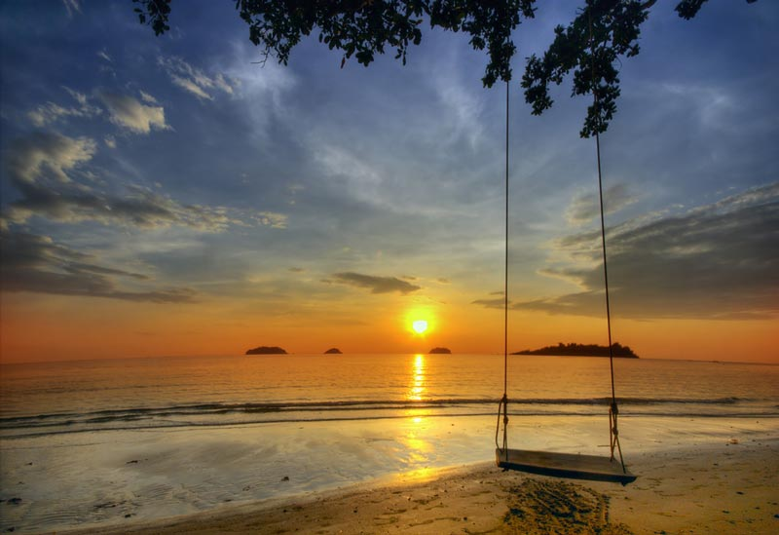
Koh Chang Package 4 Days 3 Nights . 9,200.- Baht / Per person
(Min. 2 Persons)
DAY 1
06.30 a.m. Depart from the resort Bangkok office by van
12.00 a.m. Arrive at Koh Chang Resort & Spa
Get welcome drink & check in
Have lunch at the sunset seaside restaurant.
Evening dinner.

DAY 2
07.00 a.m. Breakfast
08.30 a.m. Sightseeing and skin dive at Koh Kra Island with lunch box.
Evening dinner

DAY 3
07.00 a.m. Breakfast
09.00 a.m. Sightseeing and skin dive at Koh Yuak with lunch box.
Evening dinner.

DAY 4
07.00 a.m. Breakfast
09.00 a.m. Take a trip to Klongplu Waterfall.
12.00 a.m. Have lunch and get ready for departure
01.15 p.m. Departure from the resort.
About
07.30 p.m. Arrive at your hotel in Bangkok and farewell.

THE PACKAGE INCLUDED
- Transfer round trip: Bangkok - Resort - Bangkok
- Welcome drink
- 3 Nights accommodation (twin sharing) + 10 meals.
- 3 Activities
Exclusions:
- Optional tours or excursions not mentioned in the program
- Other meals not mentioned in the program
- Personal expenses
- Services change 3.5% pay by credit cards
Addition :
- For The Squid Cashing (07.00 PM.-10.00 PM.) Only 390 Bath/Person (includes equipment + grill + water).
- Upgrade To Deluxe With Jacuzzi Type : 1,650 Bath Will Be Added.
- New Year Eve (31 Dec.) : 1,050 Bath Will Be Added For Grand Dinner Extra Cost.
Remark : Pick up anywhere in Bangkok before 06.00 A.M. : Extra charge 300 Baht/person.
* PACKAGE PROGRAME IS SUBJECTED TO CHANGE WITHOUT PRIOR NOTICE *

