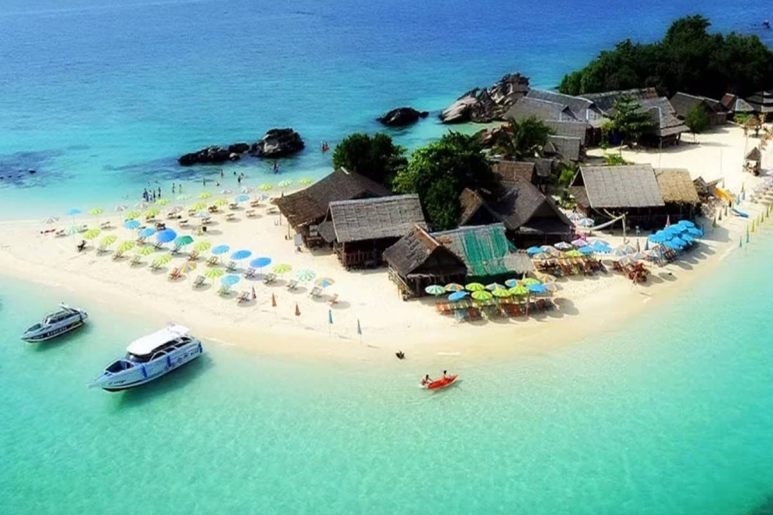
Krabi One Day Tour Khai Island By Speed Boat
( Adult 1,700 Baht/Person Child 1,200 Baht/Person )

08.00 - 08.30 am. Pick up and transfer to the pier.
09.00 am. Departure from the pier to khai Nui Island
09.30 am. Arrive at khai nui Island for snorkeling in crystal clear water above the coral with colorful fishes.
10.15 am. Departure from khai Nui Island for Khai Nok Island.
10.30 am. Arrive at khai Nok Island to enjoy snorkeling and feed colorful fishes and enjoy your time. Swimming in the clear shallow water of the bay, or simply relax on the Beach.
12.00 am. Departure from khai Nok Island for khai Nai Island
12.15 pm. Arrive at khai Nai Island. Enjoy a great lunch at restaurant. After lunch relax or enjoy your time swimming and snorkeling in the clear shallow water.
01.30 pm. Departure from khai Nai Island to the pier
02.00 pm. Arrive at your hotel by pleasant trip.

Tour Itinerary
Include : Lunch, fruit and cool soft drinks, Mask, Snorkel and Life jacket, tour guide ,Life insurance
Exclusions:
- Optional tours or excursions not mentioned in the program
- Other meals not mentioned in the program
- Personal expenses
- Services change 3.5% pay by credit cards
Remark :
- Operate high season only
- This program is subject to change according to the weather and sea conditions
*PRICE AND ITINERARY ARE SUBJECT TO CHANGE WITHOUT PRIOR NOTICE*

