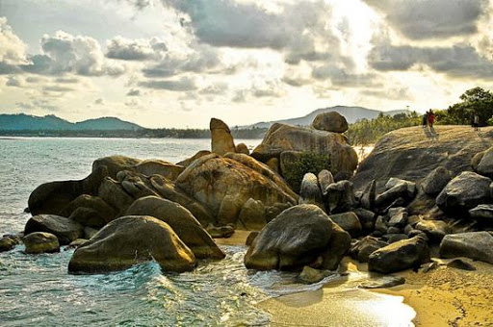
Jungle Safari Tour
09.00 Pick-up from hotel by 4WD Jeep. The first stop at “Grand Father Grand Mother rocks” after that we go to see the monkey work coconuts at Ban Hua Tanon. Then go to Waterfall for Elephant trekking 30 mines, after that start to the jungle mountain of Samui visit Magic Garden, Tanim Waterfall. We reach the summit of Samui Island with magnificent panoramic views of all the surrounding Island relax to sumptuous Thai lunch with just sounds of nature with lime to relax or explore. Our ascent through Jungle & Rain forests passes by Pineapple plantation, Rubber plantation and stop there, gradually back to the sound of civilization. We reach the Big Buddha Temple and pay visit there
Set duration 8 hours every day, 1,650 baht per person included lunch, fruits, Insurance, Elephant trekking 30 min.
*PRICE AND ITINERARY ARE SUBJECT TO CHANGE WITHOUT PRIOR NOTICE*

