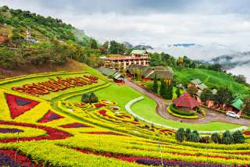
Doi Mae Salong [KMT] Chinese Community & Hill Tribe Villages

Half day tour ( 08:30 a.m. - 12:30 a.m. / 01:00 p.m. - 05:00 p.m. )
Drive to Doi Mae Salong Moutain, on the way stops at various hill tribe villages including visit Yao & Akha Hill tribe Villages. Continue to Santi Kiri KMT (Kuo Min Tung Chinese) Yunnan Chinese Refugee settlement, with its tea & coffee plantations and also co-op store where homemade wines, medical herbs and other locally grown products are sold. The villagers are ethnic Chinese, descendants of KMT Nationalist Chinese army regiment that took refuge in Thailand almost 50 years ago when Communist Forces won the civil war in mainland China. Enjoys a cool and refreshing climate all year round. In January, Japanese Sakura flowers cover the hillsides. It is known for its enchanting beautiful scenery
Half Day Tour  (Price Per Person in Thai Baht) | 1 | 2 | 3-5 | 6-8 | Join Tour
Doi Mae Salong [KMT] Chinese Community & Hill Tribe Villages | 3400 | 2000 | 1600 | 1200 | -
*PRICE AND ITINERARY ARE SUBJECT TO CHANGE WITHOUT PRIOR NOTICE*

