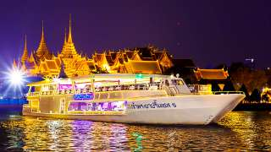

Dinner Cruise (07.00 p.m. - 09.30 p.m.)
(1,500.- Baht / Person)
Itinerary
07.00 p.m.
Check-in at La Grande Parle Restaurant, River City Shopping Complex.
07.20 p.m.
Boarding the Grand Pearl, the most luxury cruise liner on the Chao Phraya River. Welcoming by our crew in typical ceremonious Thai culture with warm smiles and offering our very own special Grand Pearl welcome cocktail.
07:30 p.m.
Departure from River City Pier While you enjoy your drinks, take in the beautiful night-lit scenery on both side of the Chao Phraya River. Our captain will pilot the boat up- River. We will ensure the opportunity for you to take snapshot of the two most magnificent night views of Bangkok: Wat Arun - The Temple of Dawn - and the Grand Palace with Wat Pra Kaew - The Temple of the Emerald Buddha. After the picture op we will return to The River City Shopping Complex, enjoying the beautiful decorations and awesome sight of colored light on the river side.
08:00 p.m.
Dinner is served under moonlight, with “Live Music” in a serenade atmosphere and a Thai Classical Dance Show. You will delight in the Thai and International cuisine offerings in a sumptuous buffet with a Sushi corner prepared with high skill and renowned car to sooth your pallet and enhance your experience with us.
08:30 p.m.
Arrival at the River City Pier. And we are sure that you will have enjoyed our Amazing Dinner Cruise. Thank you so kindly for entrusting us with this memorable evening.
Price Is Included :
- Welcome drink and snack
- Thai and International buffet dinner
- Live music
- Boat cruising of approx.2 hours.
Price Exclude :
- Personal Expense
- Service charge 3.5% for paying by credit card charge

*PRICE AND ITINERARY ARE SUBJECT TO CHANGE WITHOUT PRIOR NOTICE*

