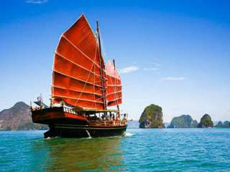

Phuket June Bahtra in Phuket
Twilight Cruise for Late-Risers

Every Thursdays and Saturdays
You will be picked up from your hotel at around 01.00 p.m. , and you will get to know your fellow adventurers by means of shared transportation to the Yacht Haven Marina, where you will board the June Bahtra. The journey onboard this wonderful
boat will take you through the amazing Andaman Phang Nga Bay, with its magnificent limestone creations.
You will visit James bond island around 04:15 p.m. , a time when most tourist boats are already back in Phuket, thus promising you an exclusive view of the island and the famous rock formations.
Thereafter, the June Bahtra sets sail to return to Phuket. On the way, you will enjoy swimming in the sea while watching one of the most romantic sunset scenes imaginable. Enjoy drinks and snacks on your return journey, and arrive back in your hotel at around 08:30 p.m. , just in time to start your nightlife.

Price Includes :
- Transfer from/to hotel and pier Yacht Haven Marina
- Soft drinks
- Thai lunch on board with tea and coffee.
- Bilingual speaking guide;
- German/English – speaking guide: Tuesdays and Saturdays
- French/English - speaking guide: Wednesdays and Fridays
Prices Exclude :
- Other services not mentioned in package.
- Other drinks and meals not mentioned in package.
- Other personal expenses.
- Service charge 3.5% for paying by credit card
Note : Asian Oasis reserves the right to replace this program by our regular full-day tour, should the minimum number of 8 guests not be reached. In this case, no additional charges will occur for the guests
*PRICE AND ITINERARY ARE SUBJECT TO CHANGE WITHOUT PRIOR NOTICE*

