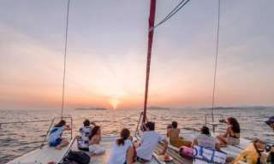

Phuket Sunset Dinner Cruise in Phang Nga Bay

Depart on every Wednesday & Saturday 04:00 p.m. - 09:00 p.m.
You will be picked up from the hotel at approximately 03:30 p.m. and be transferred to the embarkation pier at Yacht Haven Marina by air - conditioned bus. Embark on "JUNE BAHTRA" for a 05:00 p.m. departure and cruise through Ko Lawa for a
spectacular sunset over Phang Nga Bay. A delicious buffet dinner is served on board. Cruise back to Yacht Haven Marina and transfer back to the hotel. Arrive at the hotel approximately 09:30 p.m.
Price Net rates per person in THB

Price Includes :
- Transfer from/to hotel and Yacht Haven Marina.
- Welcome drink and cashew nuts upon arrival on board.
- Thai buffet dinner on board.
- Bottled water and soft drinks.
Prices Exclude :
- Other services not mentioned in package.
- Other drinks and meals not mentioned in package.
- Other personal expenses.
- Service charge 3.5% for paying by credit card
Remarks :
- For safety reasons and according to weather conditions, the program may be amended without prior notice.
- Child Rate: Children under the age of 12 will receive a 50% discount of the published rates.
- Infants (under 2 years old) are free of charge.
- Group concession: 1 person FOC for 15 paying persons
- The above tour prices include service and government tax.
- Alcoholic beverages are available at extra cost.
*PRICE AND ITINERARY ARE SUBJECT TO CHANGE WITHOUT PRIOR NOTICE*

