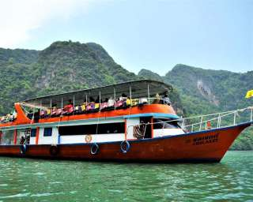

Phuket James Bond Island (Phang Nga Bay) Tour by Big boat + Canoe
(Adult 1700.- Baht / Person Child 1500.- Baht / Person)

The Sea Mountains of Phang Nga Bay are so dramatic, that they impress everybody who ventures here. If you are really nature lover and concentrate to environment, it is completely appreciated. Our aim is to get you closer to the nature. In the same time, it is opportunity to touch with local people

Itinerary:
- 08.00 a.m. Pick up time from hotel
- 08.45 a.m. Escort boat leave to Phang-Nga Bay
- 09.45 a.m. Visit Panak Island, canoeing in cave
- 12.15 a.m. Visit James Bond Island
- 12.40 a.m. Lunch on the board
- 01.30 p.m. Canoeing in Hong Island
- 03.00 p.m. Visit Naka Bay or Lawa Island for swimming and canoeing by yourself
- 04.00 p.m. Back to Ao Po pier

Tour Price included :
- Land Transfer Hotel / Pier / Hotel.
- Coffee / Tea / Soft Drink / Seasonal fruits.
- Set lunch menu.
- Life Jackets.
- Canoe equipment with well-trained canoe paddler.
- Insurance.
- Educated staff.
- Excellent service.
Price excludes :
- Personal Expense
- Service charge 3.5% for paying by credit card charge

*PRICE AND ITINERARY ARE SUBJECT TO CHANGE WITHOUT PRIOR NOTICE*

