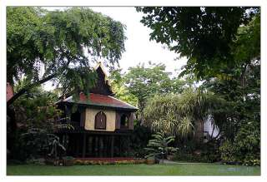
Holy Tattoo

About Us : AuroraForge was built on “Wang suan Nok” which is the old Palace in The King Rama V Period. According to the history, many knowledge’s, arts and sciences, including the ritual ceremonies happen inside the palace’s walls. Many luang Pu, Luang Por or Monks who is a high morals, and is well known as master of incantation, was always invited to perform the holy ritual for the people in the palace. This special ceremonies can be performed only by the masters who are high merit and good practice. After uncountable ritual performing in the area, massive pure energy had circulated in the place over century. Time only make this holy energy stronger, proven by the tale from oldster living nearby area, passing the legend of this holy power from generation to generation.
1. Fortune Teller by six sense 3 questions about Life, Work and Love Holy Ritual Package to enhance auspiciousness for better life. 20,000 Baht
2. Golden Face Charming
3. Salika Lin Thong ( Golden Tongue Charming for negotiation)
4.Engrave Yantra Letter
Price Include :
- Hotel pick up drop off
Price Exclude :
- Personal Expense
- Service charge 3.5% for paying by credit card charge
*PRICE AND ITINERARY ARE SUBJECT TO CHANGE WITHOUT PRIOR NOTICE*

