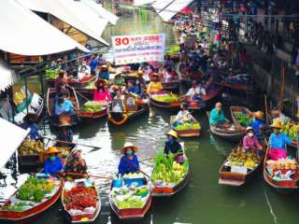

Damnernsaduak Floating Market Lunch Cultural Show At Rose Garden
(1,600 Baht / Per Person)

06.30 a.m. Pick up from the hotel
07.00 a.m. Leave Bangkok for rajaburi province.
08.32 a.m. Visit coconut sugar home industry.
09.00 a.m. Boat trip to the floating market.
09.32 a.m. Arrive floating market where young find many kind of farm product old in their sampan boat.
10.32 a.m. Short top at the handy cleft factory.
12.00 a.m. International buffet lunch.
02.31 p.m. Visit rose garden (Thai village to see Thai cultural show from every part of Thailand) finally return to Bangkok.
05.00 p.m. Arrival hotel.

Personal Expense
Price Exclude:
- Service charge 3.5% for paying by credit card charge
*PRICE AND ITINERARY ARE SUBJECT TO CHANGE WITHOUT PRIOR NOTICE*

