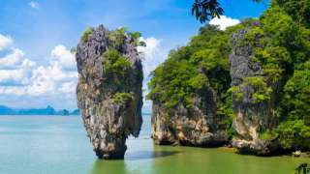

Phuket James Bond Island (Phang Nga Bay) Tour by Road + Boat
(Adult 1,400.- Baht / Person Child 1,200.- Baht / Person)

- Cave Temple (Wat Suwannakhuha).
- Mangrove Forest, along Canal Boat Cruise.
- Talu - Phang Nga Cave.
- James Bond Island (Ping Kan).
- English Speaking Guide.
- Halal Food.

Itinerary :
- 08.00 a.m. – Pick up from hotel.
- 09.30 a.m. – Visit Cave Temple, where can enjoy with monkey or worship to Reclining Buddha.
- 10.30 a.m. – Boat leave to Phang Nga Bay for sightseeing along Mangrove forest. Explore the beauty of Bay with many limestone rocks & caves.
- Visit “Khao Ping Kan” or “James Bond Island”
- 12.30 a.m. – Enjoy lunch at “Koh Pan Yee” the Floating village or Sea-Gypsy Island. Meet the local people after lunch by walking.
- 02.30 p.m. – Boat sightseeing on return way to the pier.
- 03.30 p.m. – Arrive back to the pier and proceed back to your hotel

Tour Price included:
- Transfer Hotel / Pier / Hotel.
- Coffee / Tea / Soft Drink.
- Fresh fruits, Snacks.
- Set lunch menu.
- Insurance.
- Educated staff.
- Excellent service.
Price excludes:
- Personal Expense
- Service charge 3.5% for paying by credit card charge

*PRICE AND ITINERARY ARE SUBJECT TO CHANGE WITHOUT PRIOR NOTICE*

